**FINAL SIMULATION FOR LUNGS SOUND**

**=====================================================**

**SYM 2**

| **SYM 2** | **No of Delay** | **SNRdB_Lungs_Sound** | **RMSE_Lungs_Sound** | **PRD_Lungs_Sound** | **CC_Lungs**  **_Sound** |
| --- | --- | --- | --- | --- | --- |
| Level 2 | 39 | 24.6528 dB | 9.5303e-05 | 5.8528% | 0.95883 |
| Level 3 | 72 | 24.7964 dB | 9.3716e-05 | 5.7568% | 0.96033 |
| Level 4 | 105 | 24.9619 dB | 9.1946e-05 | 5.6481% | 0.96185 |
| Level 5 | 140 | 25.5545 dB | 8.5878e-05 | 5.2757% | 0.96664 |
| Level 6 | 175 | 26.0874 dB | 8.0738e-05 | 4.9617% | 0.97051 |
| Level 7 | 210 | 26.3573 dB | 7.8305e-05 | 4.8099% | 0.9724 |

**++++++++++++++++++++++++++++++++++++++++++++++++++++++++++++++++++**

**(1) SYM 2 LEVEL 2**

(a) SYM 2 LEVEL 2 ARCHITECTURE

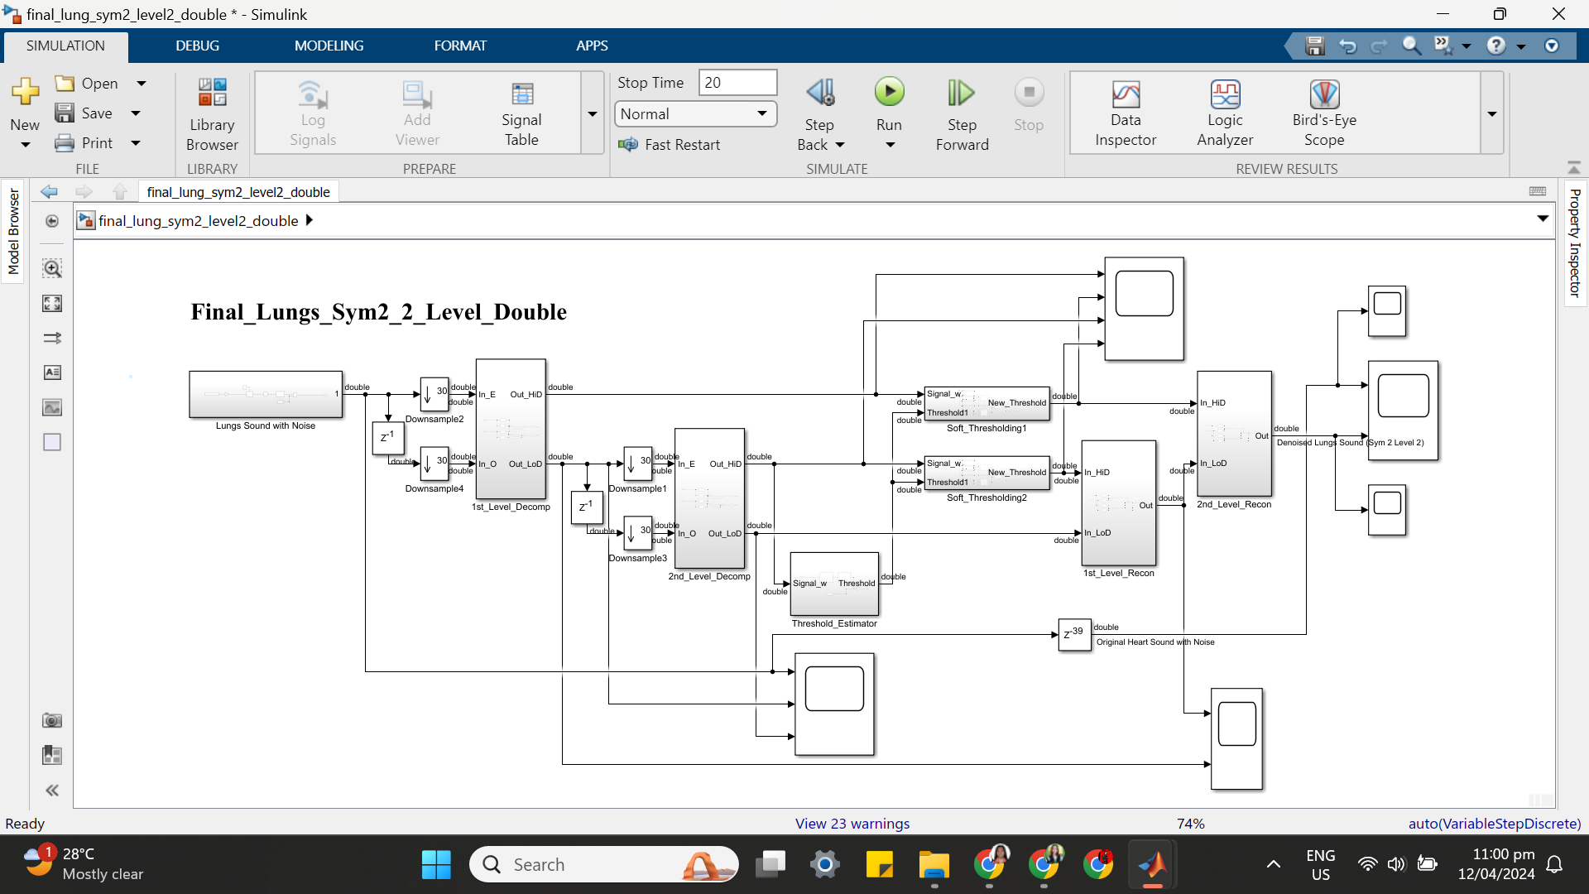

(b) SYM 2 LEVEL 2 SIMULATION RESULT

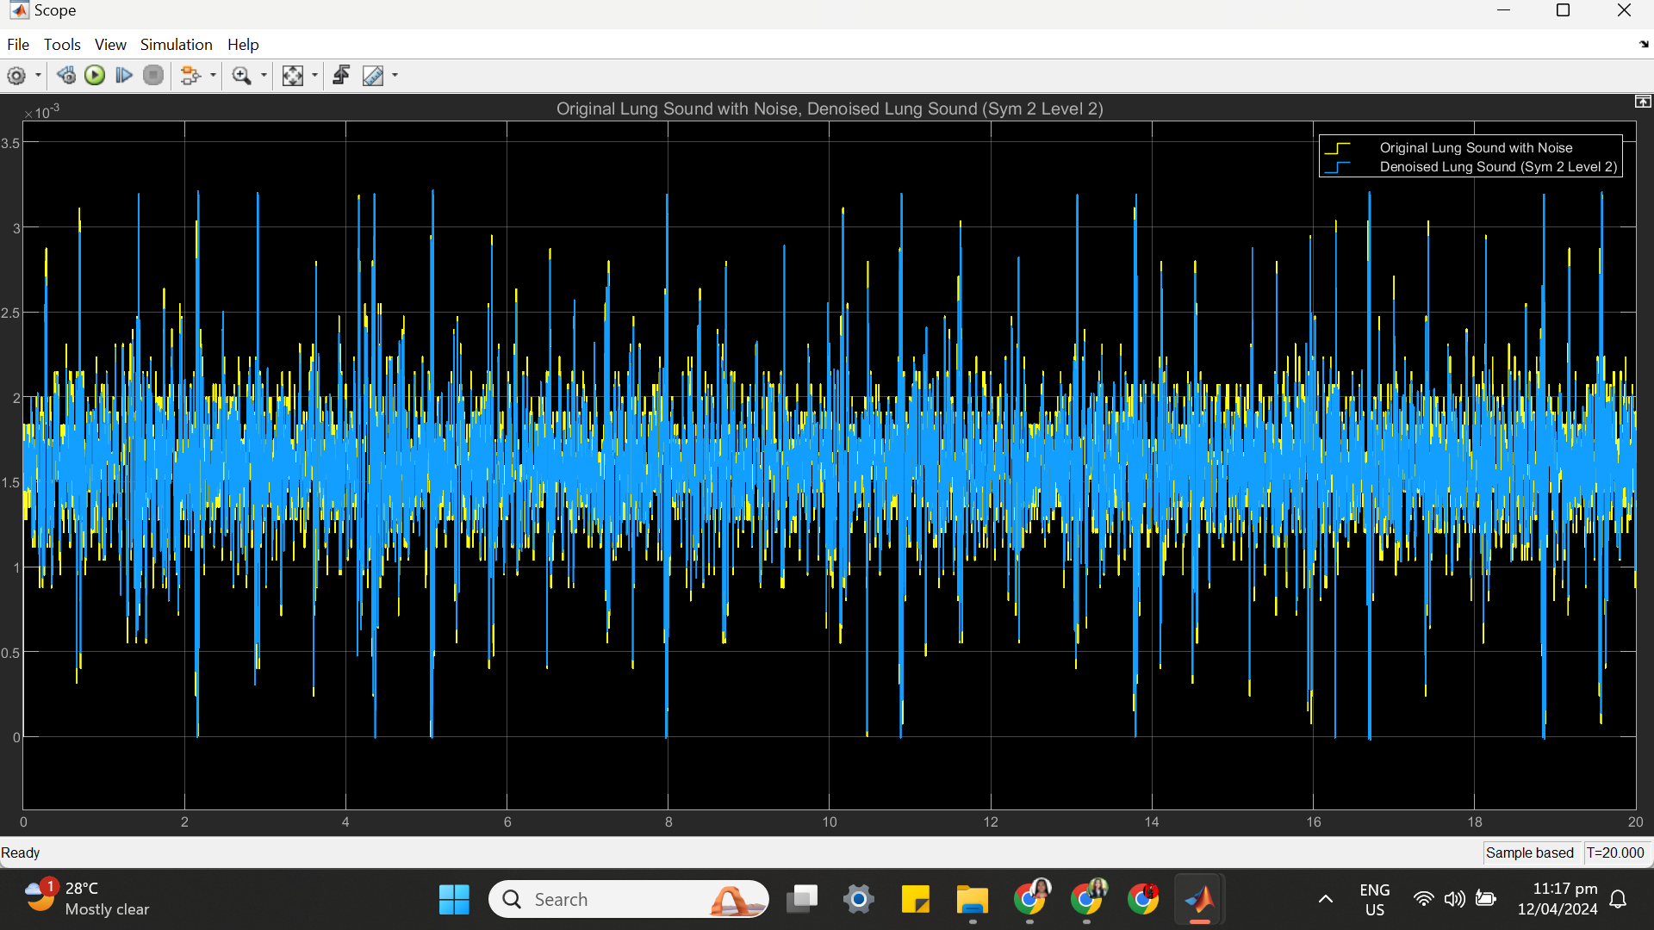

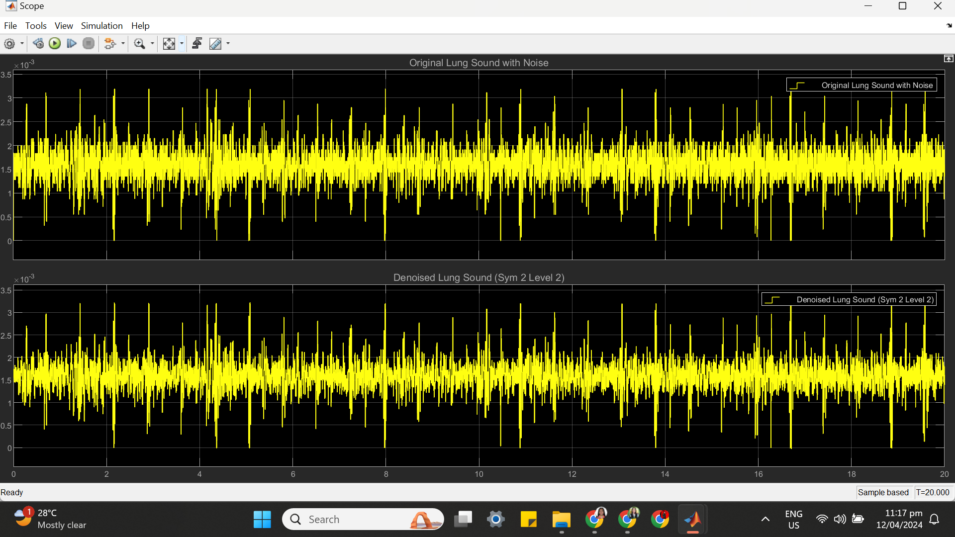

(c) SYM 2 LEVEL 2 STATISTICS RESULT

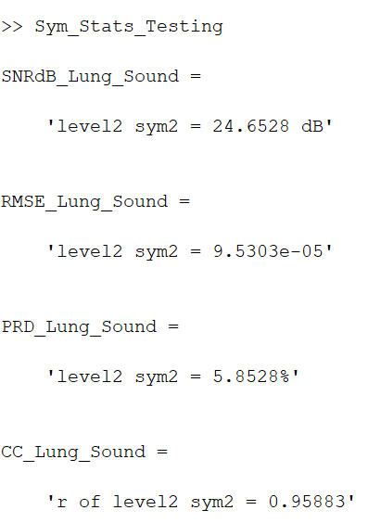

(d) SYM 2 LEVEL 2 SCATTER PLOT RESULT

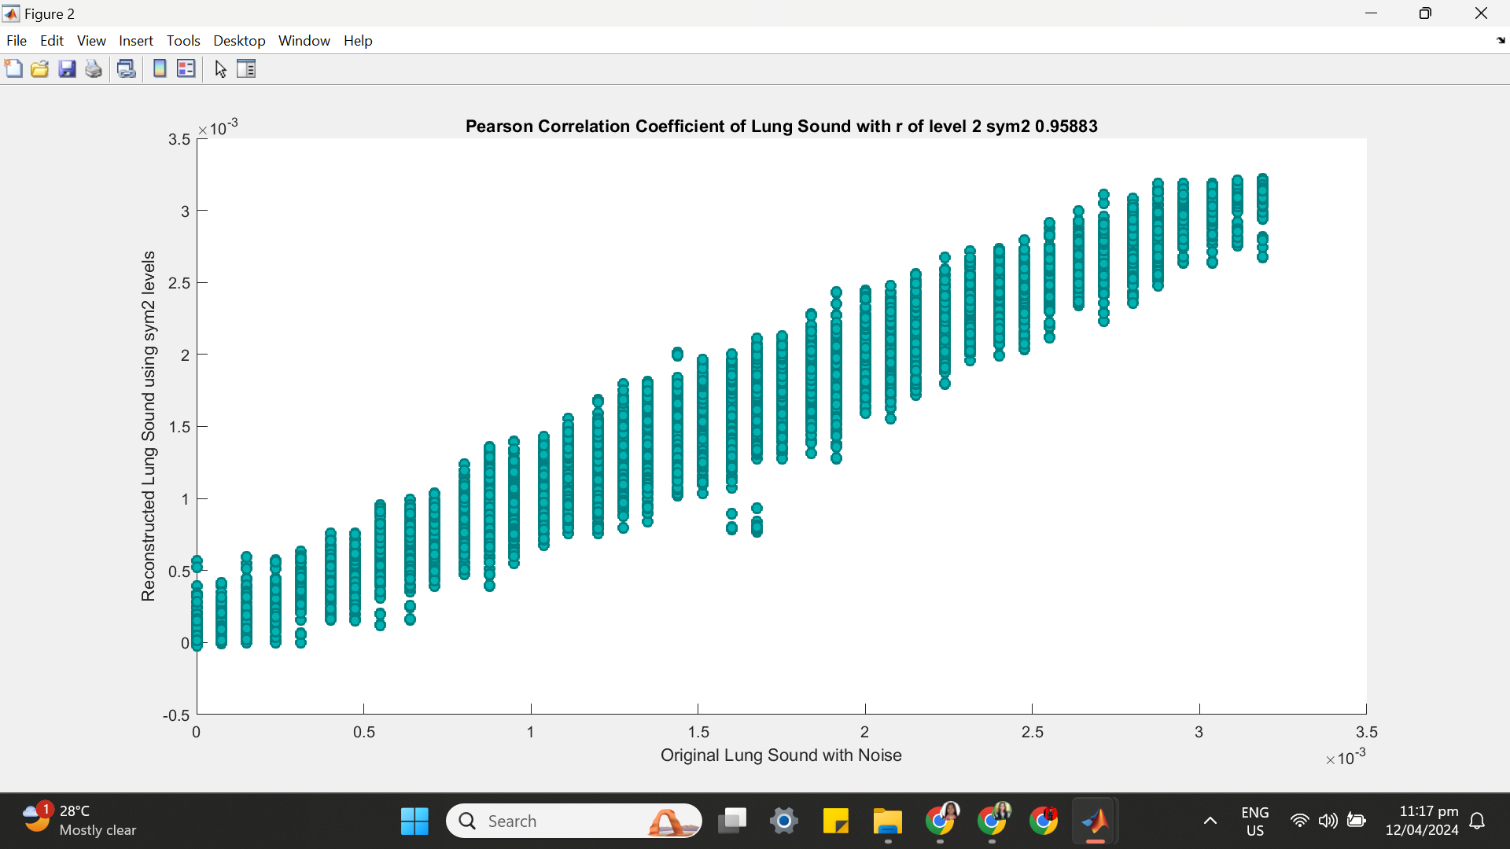

**++++++++++++++++++++++++++++++++++++++++++++++++++++++++++++++++++(2) SYM 2 LEVEL 3**

(a) SYM 2 LEVEL 3 ARCHITECTURE

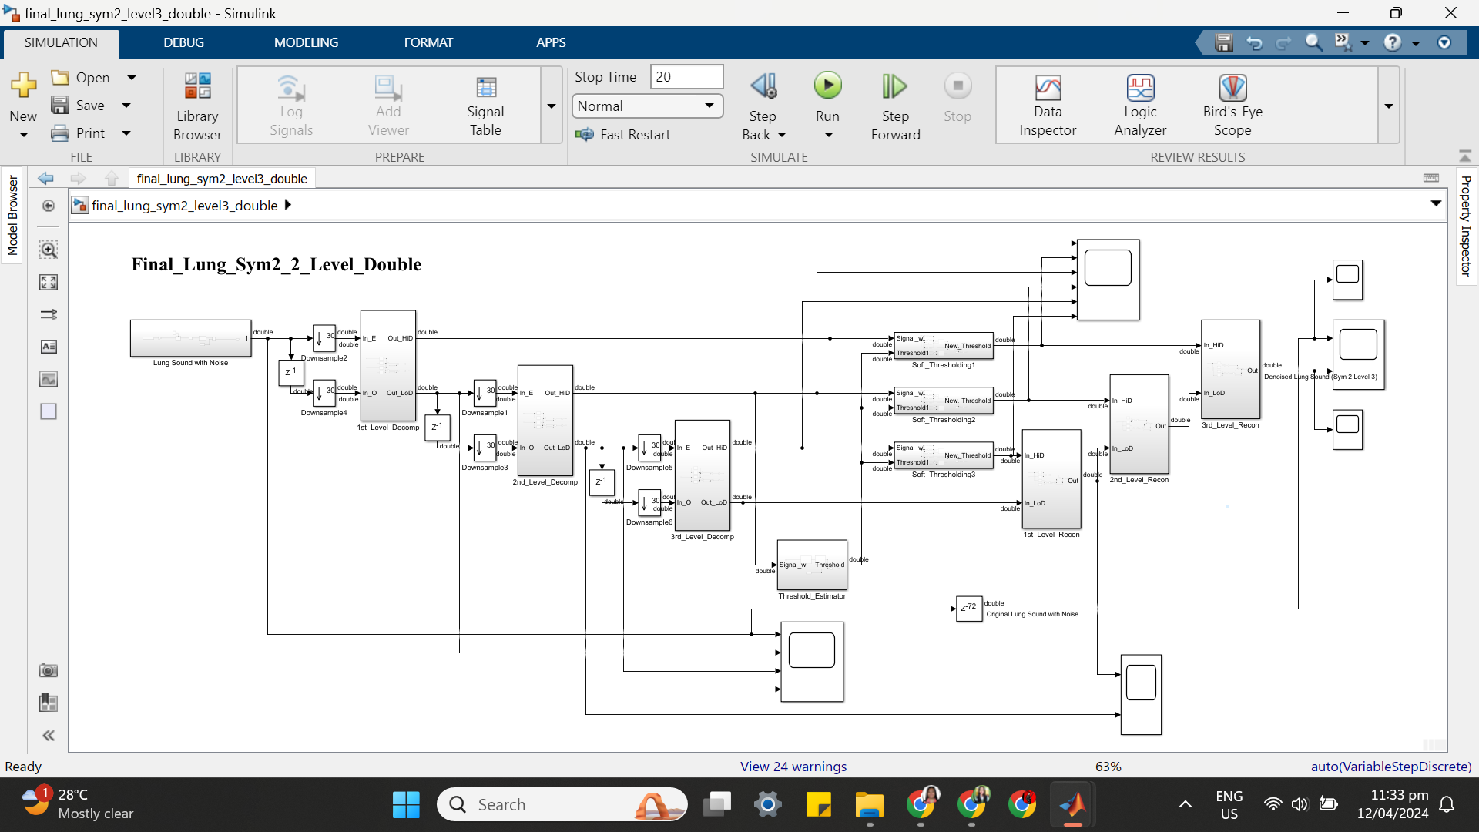

(b) SYM 2 LEVEL 3 SIMULATION RESULT

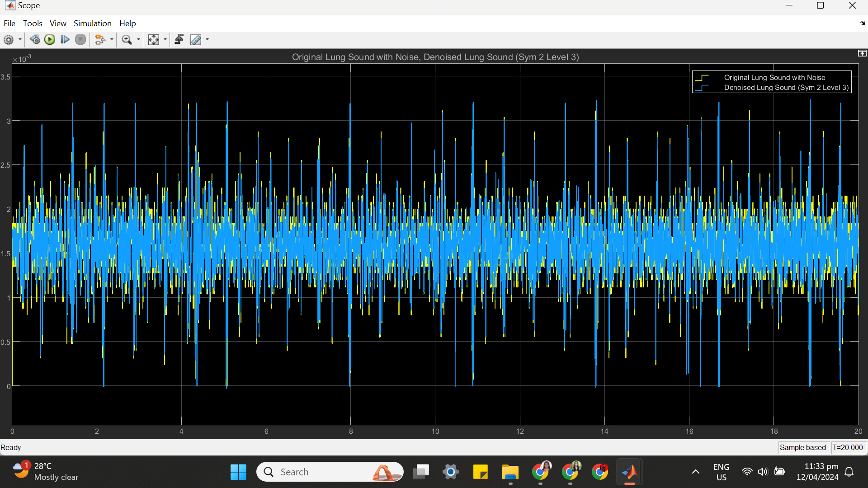

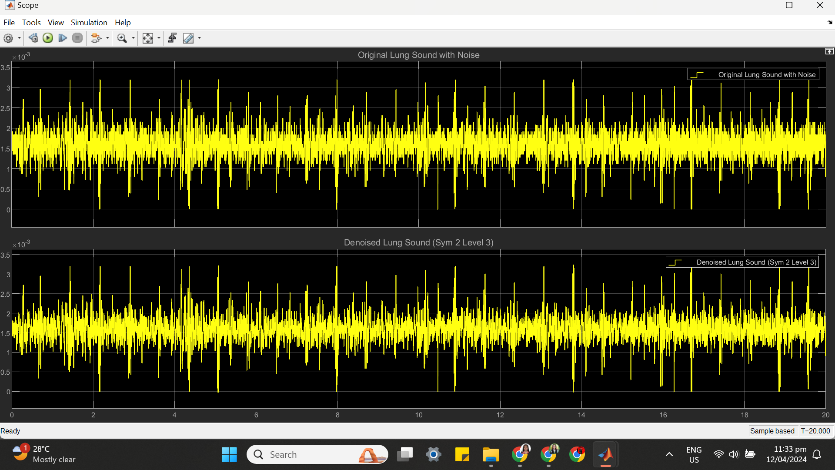

(c) SYM 2 LEVEL 3 STATISTICS RESULT

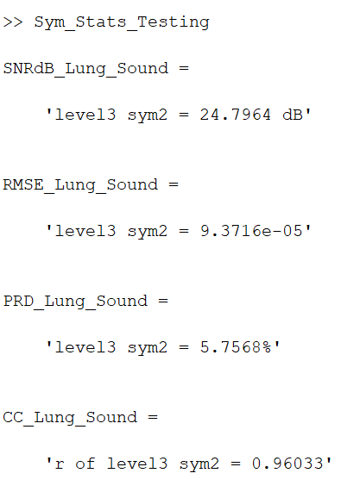

(d) SYM 2 LEVEL 3 SCATTER PLOT RESULT

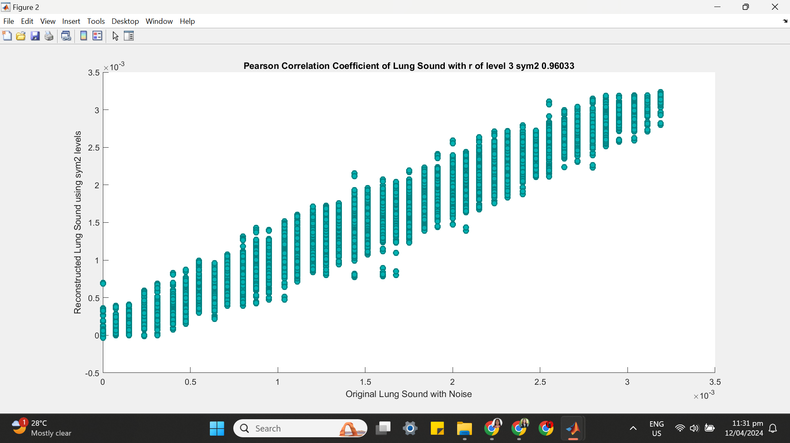

**++++++++++++++++++++++++++++++++++++++++++++++++++++++++++++++++++**

**(3) SYM 2 LEVEL 4**

(a) SYM 2 LEVEL 4 ARCHITECTURE

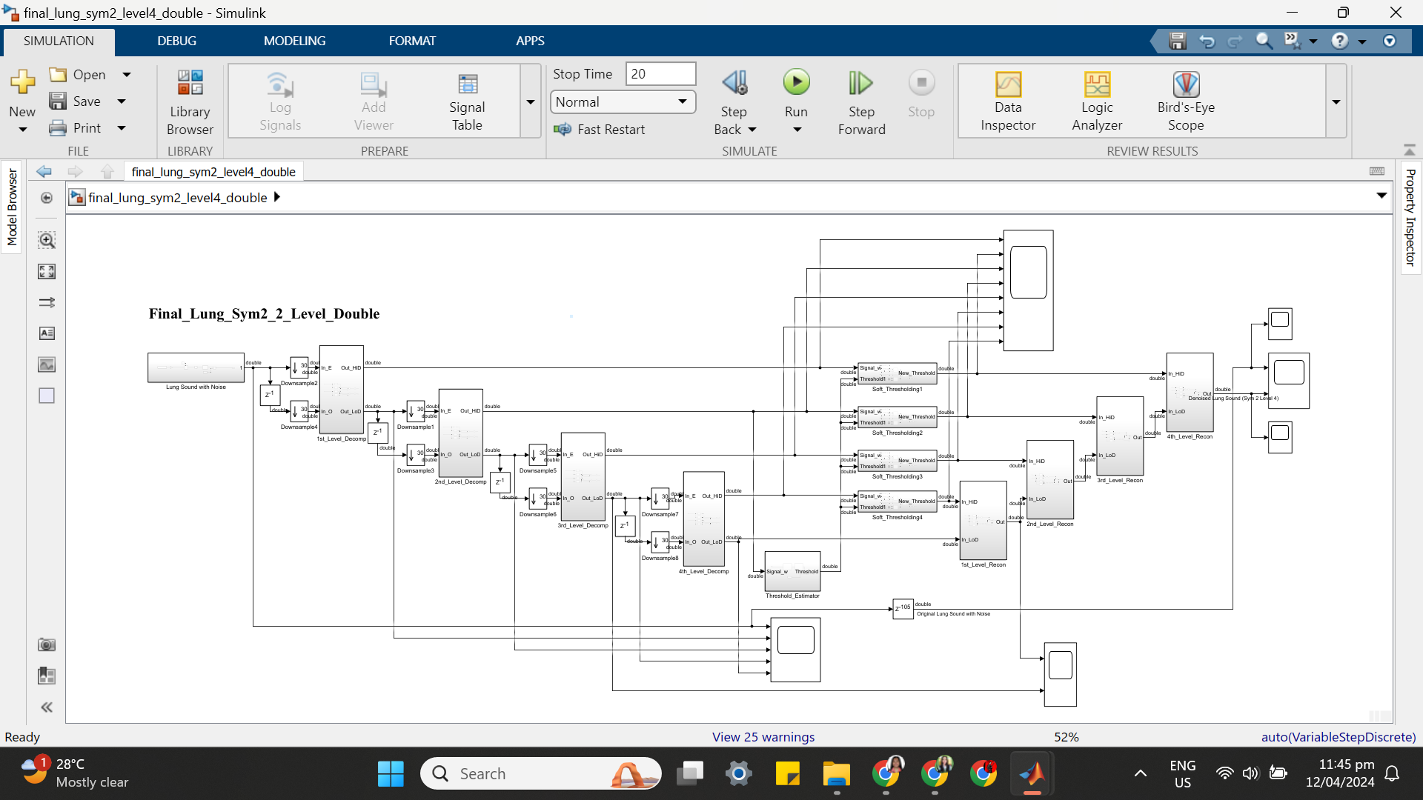

(b) SYM 2 LEVEL 4 SIMULATION RESULT

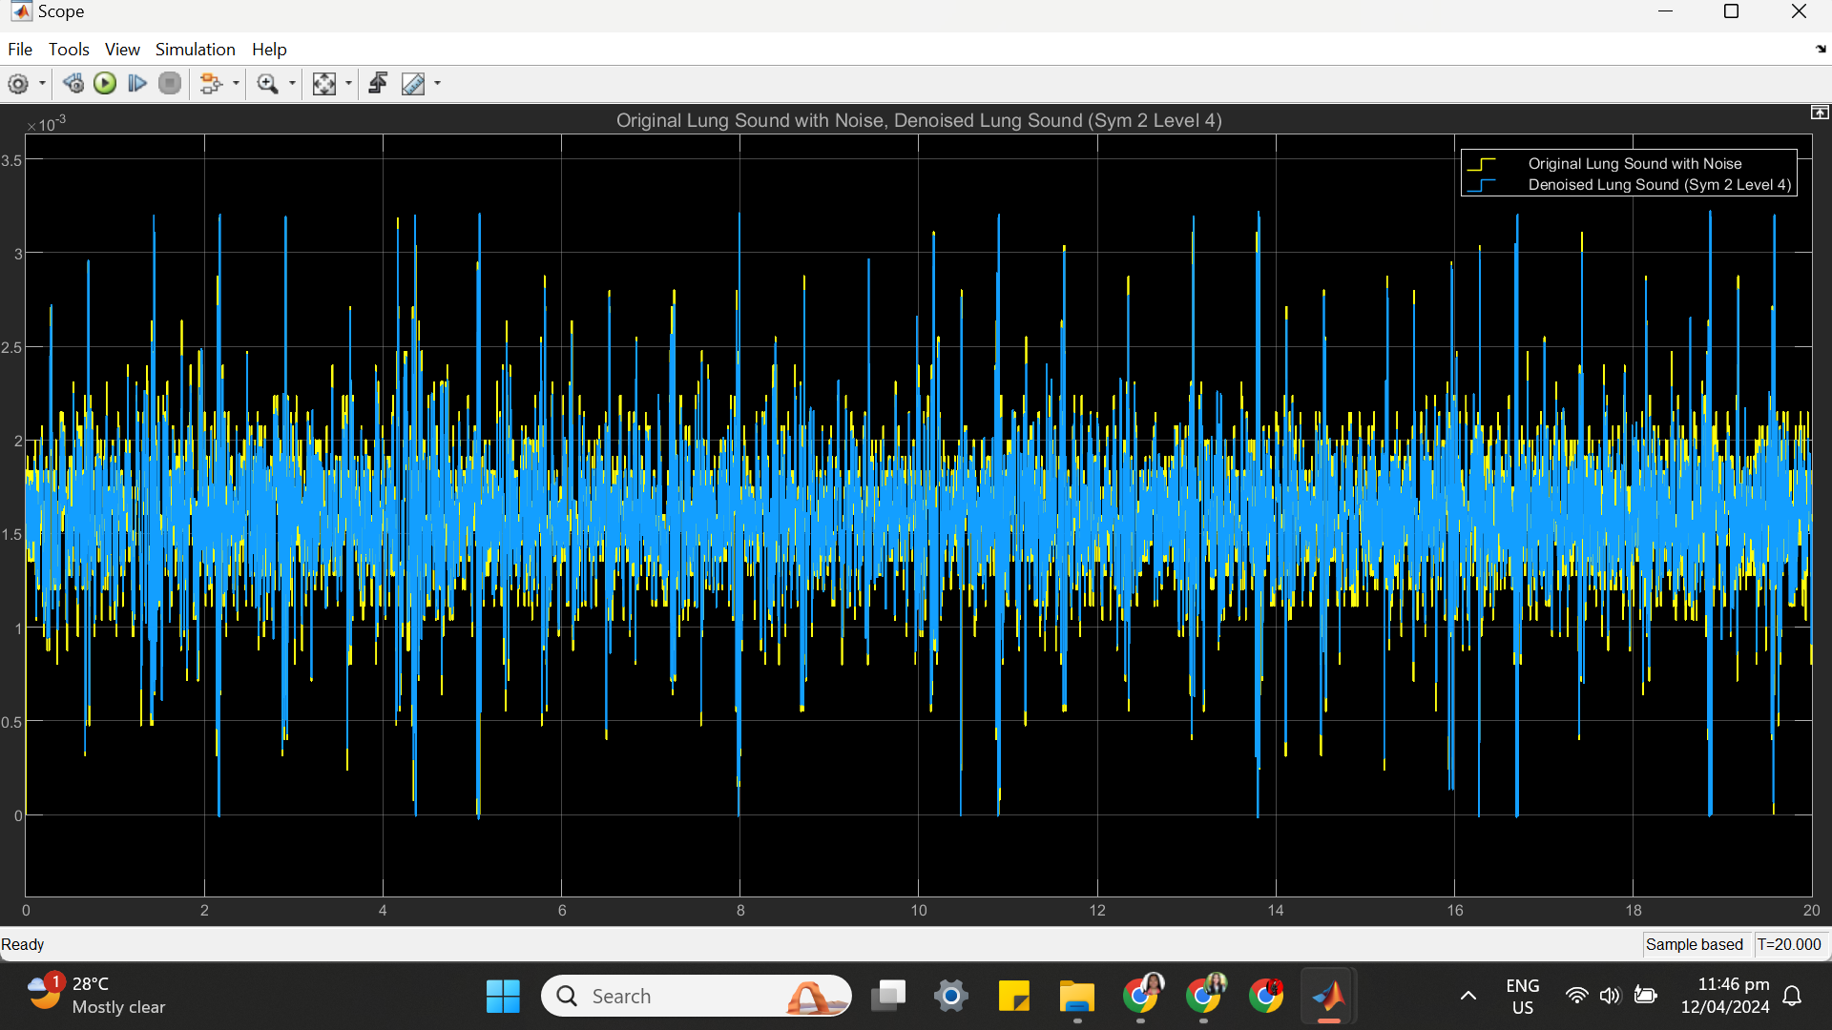

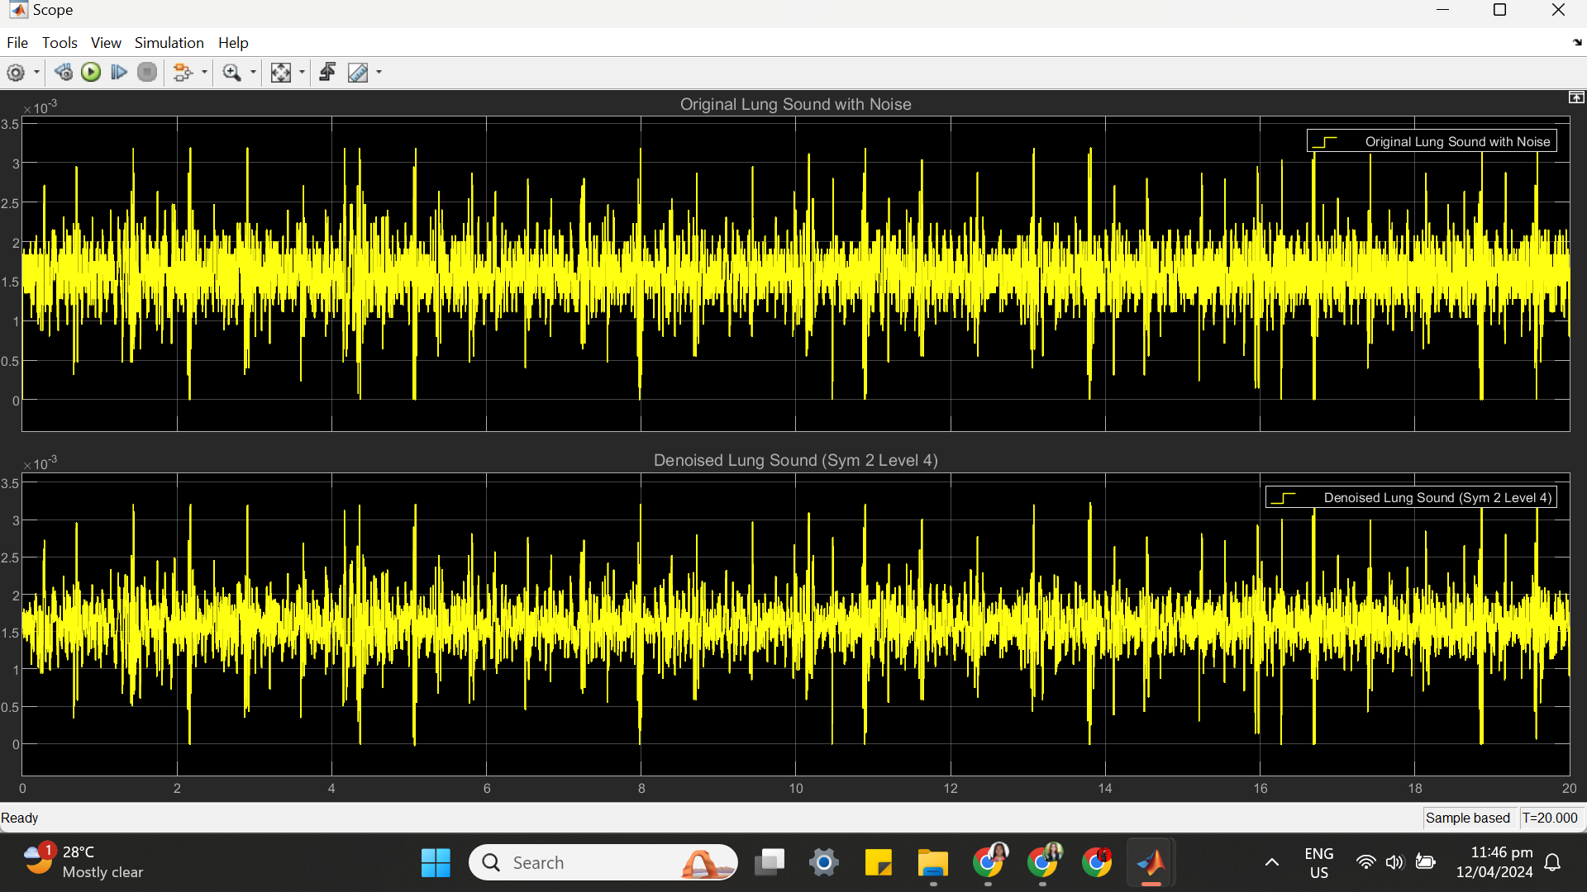

(c) SYM 2 LEVEL 4 STATISTICS RESULT

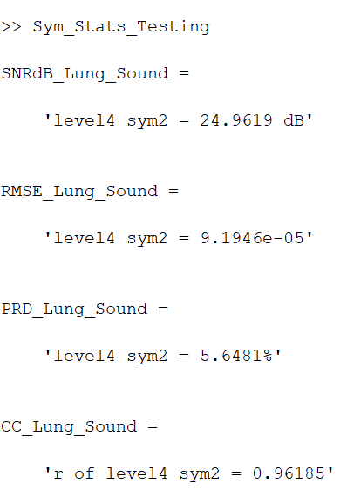

(d) SYM 2 LEVEL 4 SCATTER PLOT RESULT

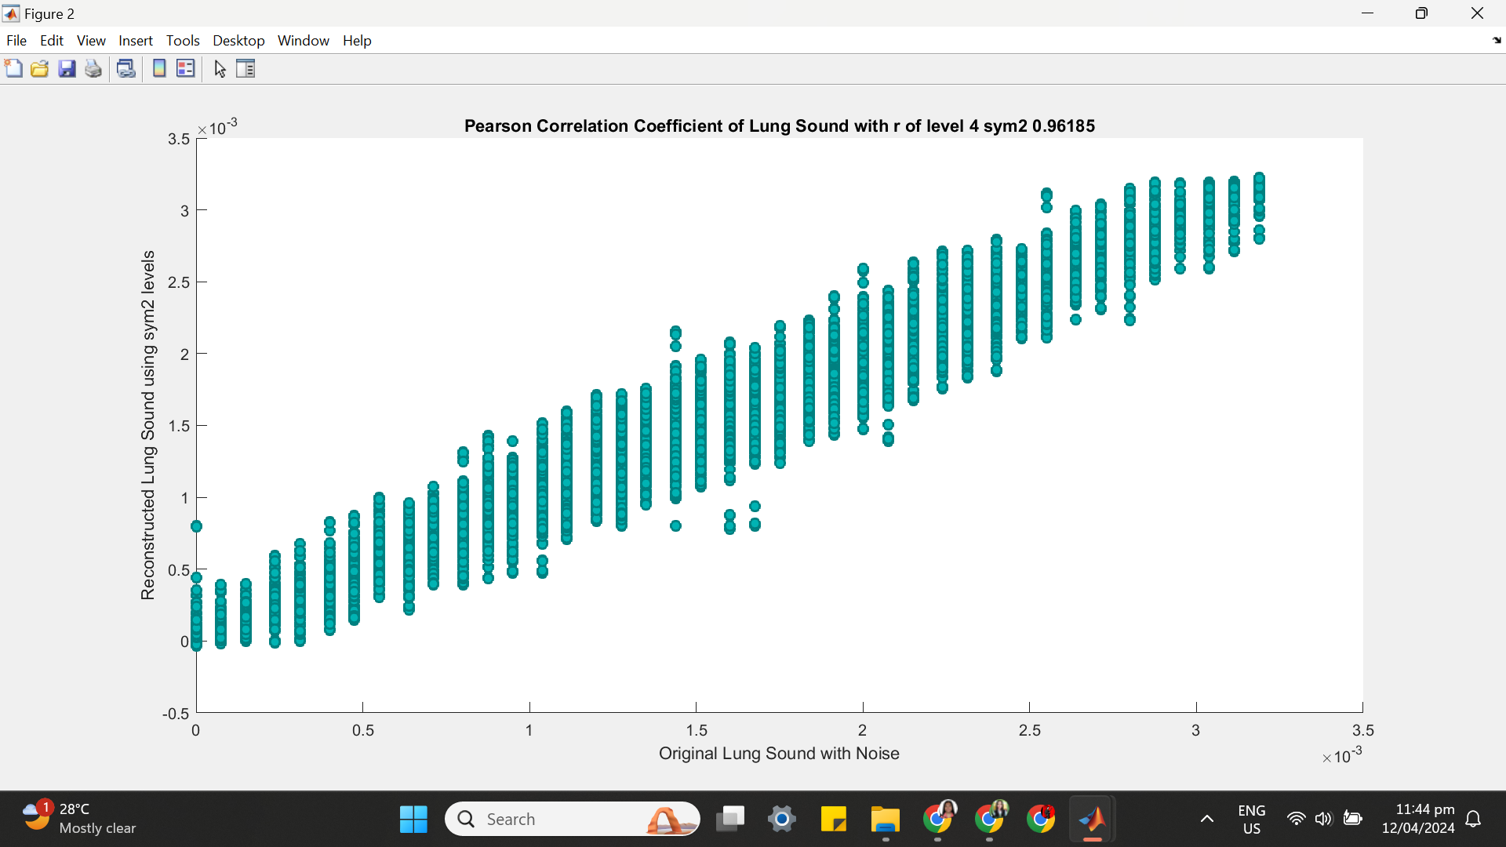

**++++++++++++++++++++++++++++++++++++++++++++++++++++++++++++++++++(4) SYM 2 LEVEL 5**

(a) SYM 2 LEVEL 5 ARCHITECTURE

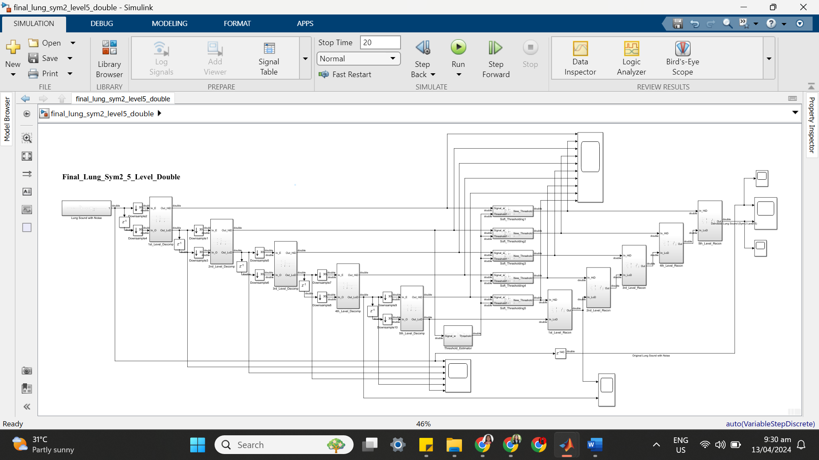

(b) SYM 2 LEVEL 5 SIMULATION RESULT

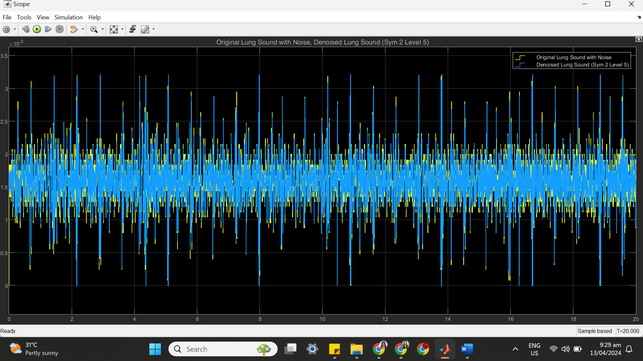

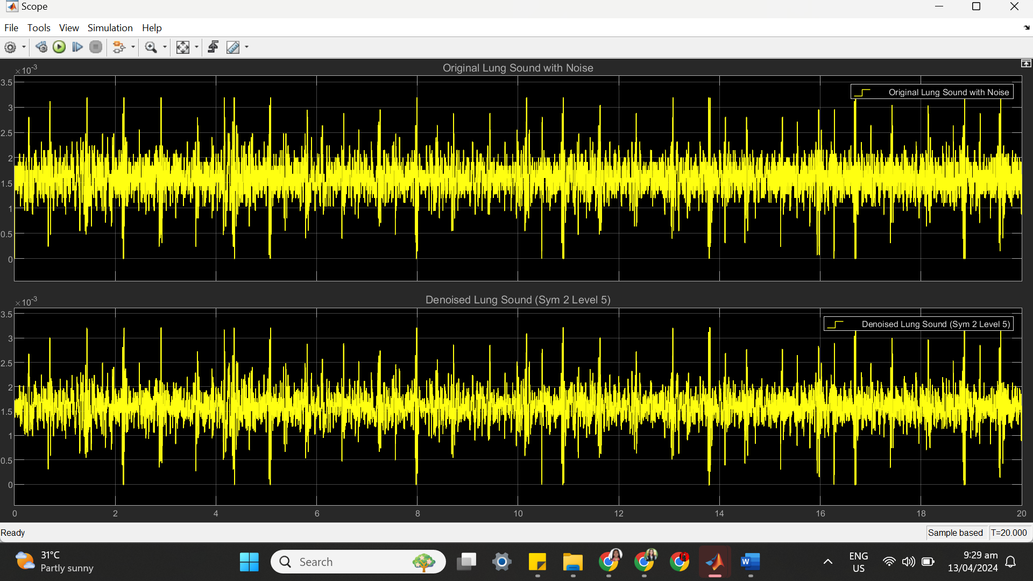

(c) SYM 2 LEVEL 5 STATISTICS RESULT

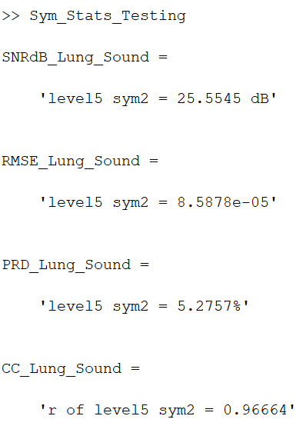

(d) SYM 2 LEVEL 5 SCATTER PLOT RESULT

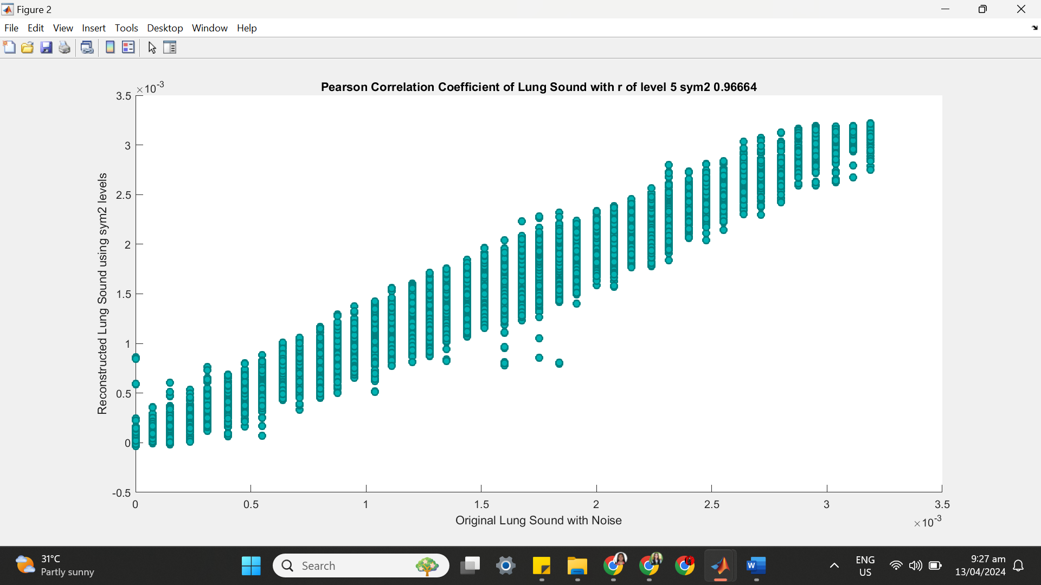

**++++++++++++++++++++++++++++++++++++++++++++++++++++++++++++++++++(5) SYM 2 LEVEL 6**

(a) SYM 2 LEVEL 6 ARCHITECTURE

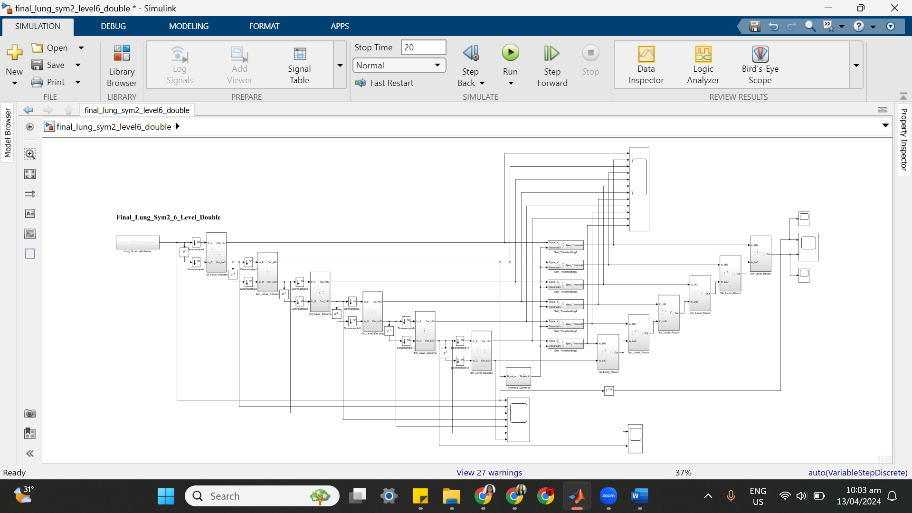

(b) SYM 2 LEVEL 6 SIMULATION RESULT

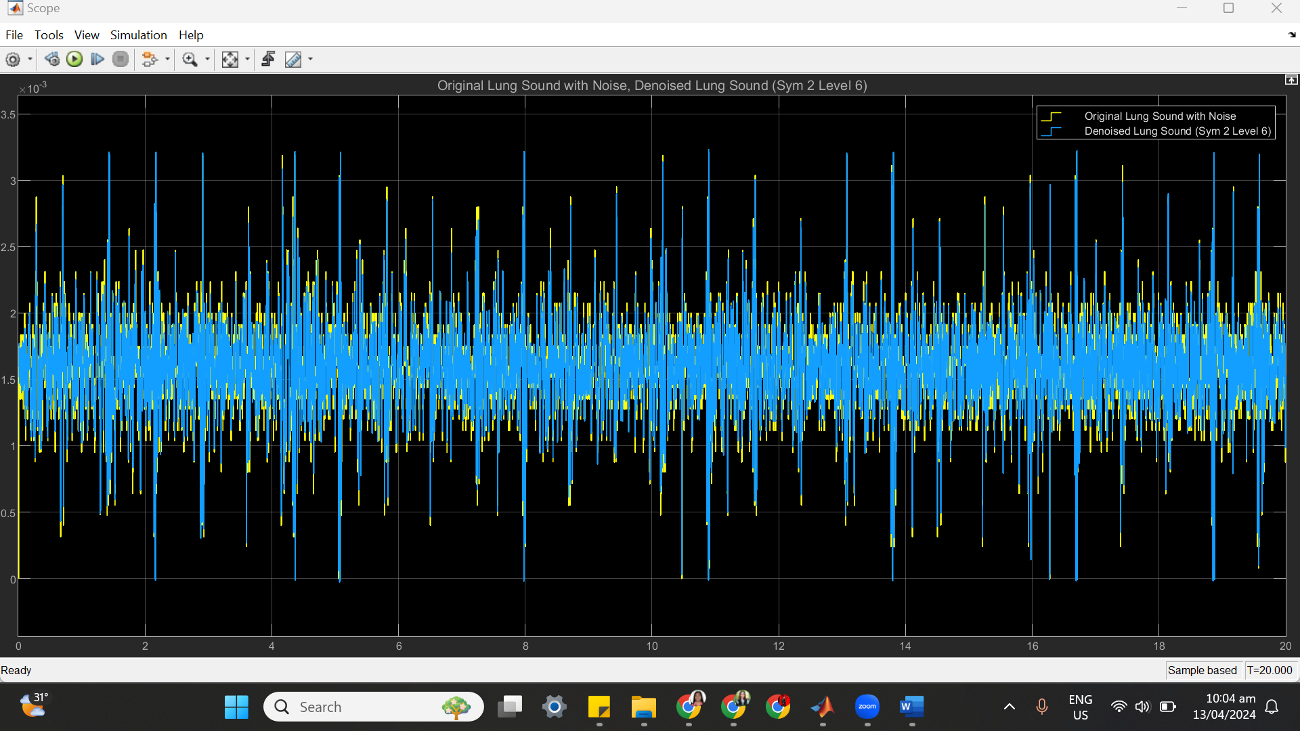

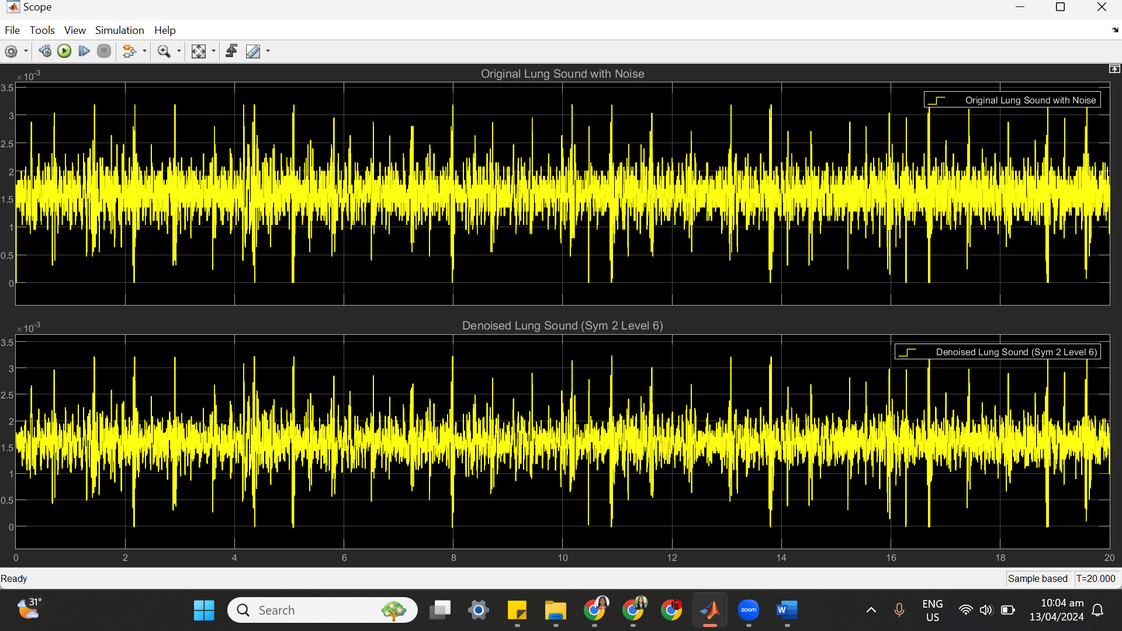

(c) SYM 2 LEVEL 6 STATISTICS RESULT

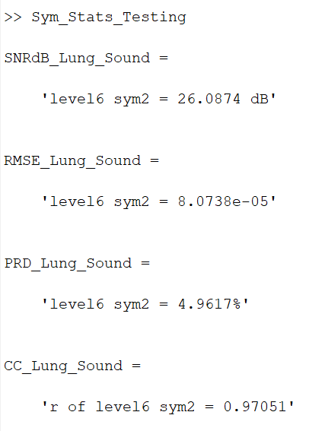

(d) SYM 2 LEVEL 6 SCATTER PLOT RESULT

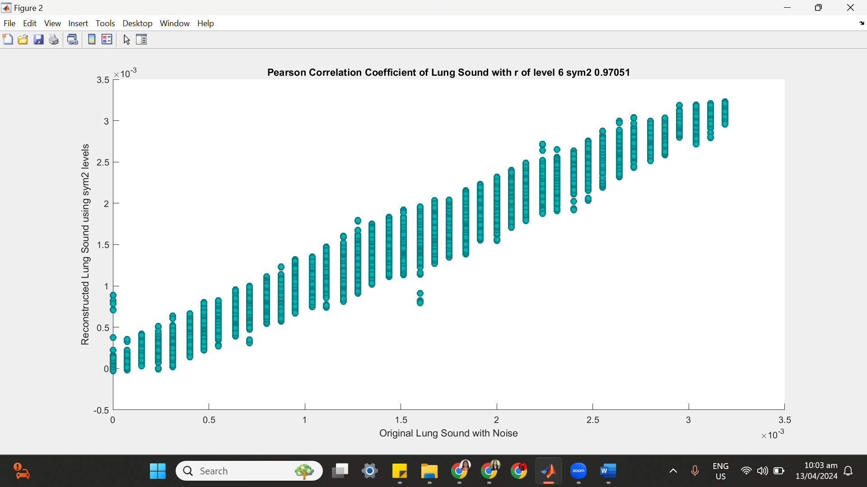

**++++++++++++++++++++++++++++++++++++++++++++++++++++++++++++++++++**

**(6) SYM 2 LEVEL 7**

(a) SYM 2 LEVEL 7 ARCHITECTURE

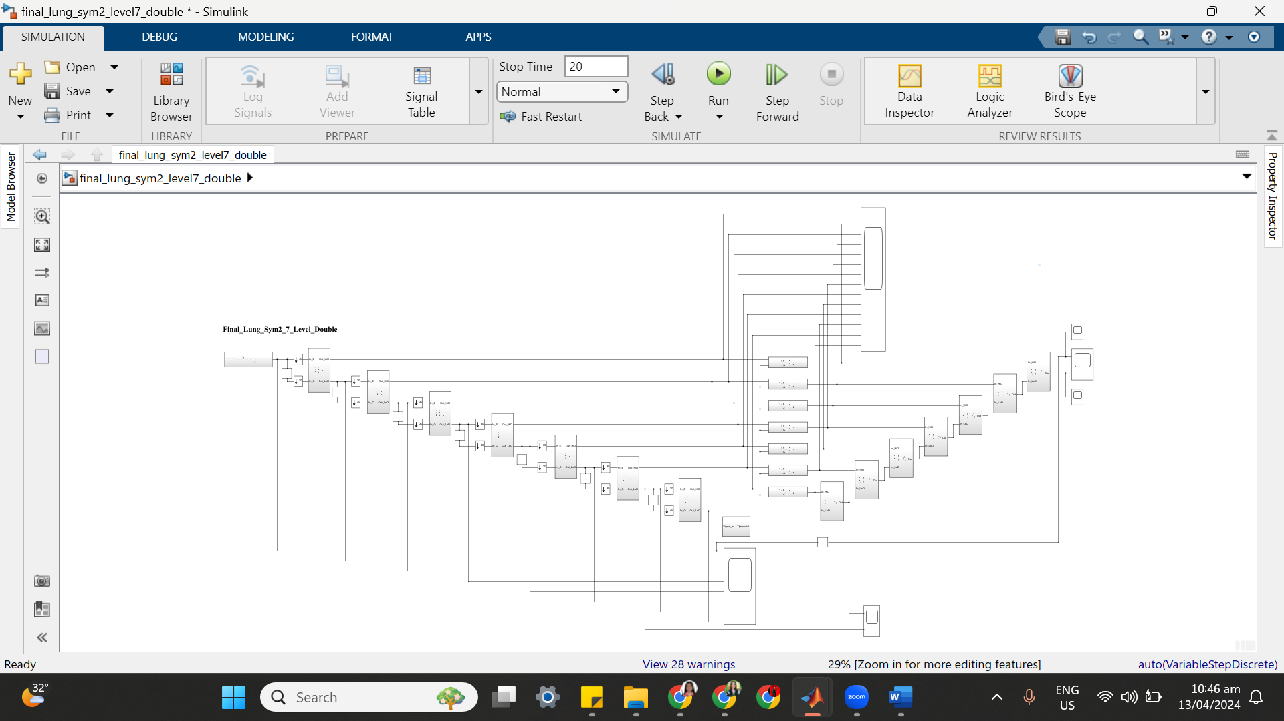

(b) SYM 2 LEVEL 7 SIMULATION RESULT

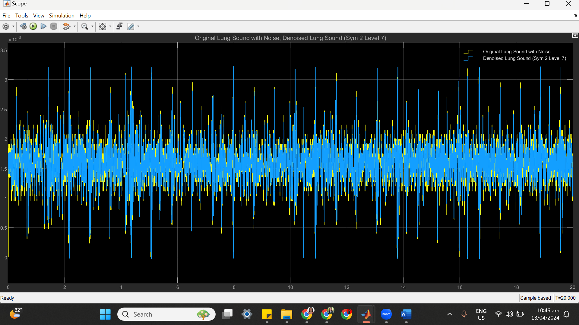

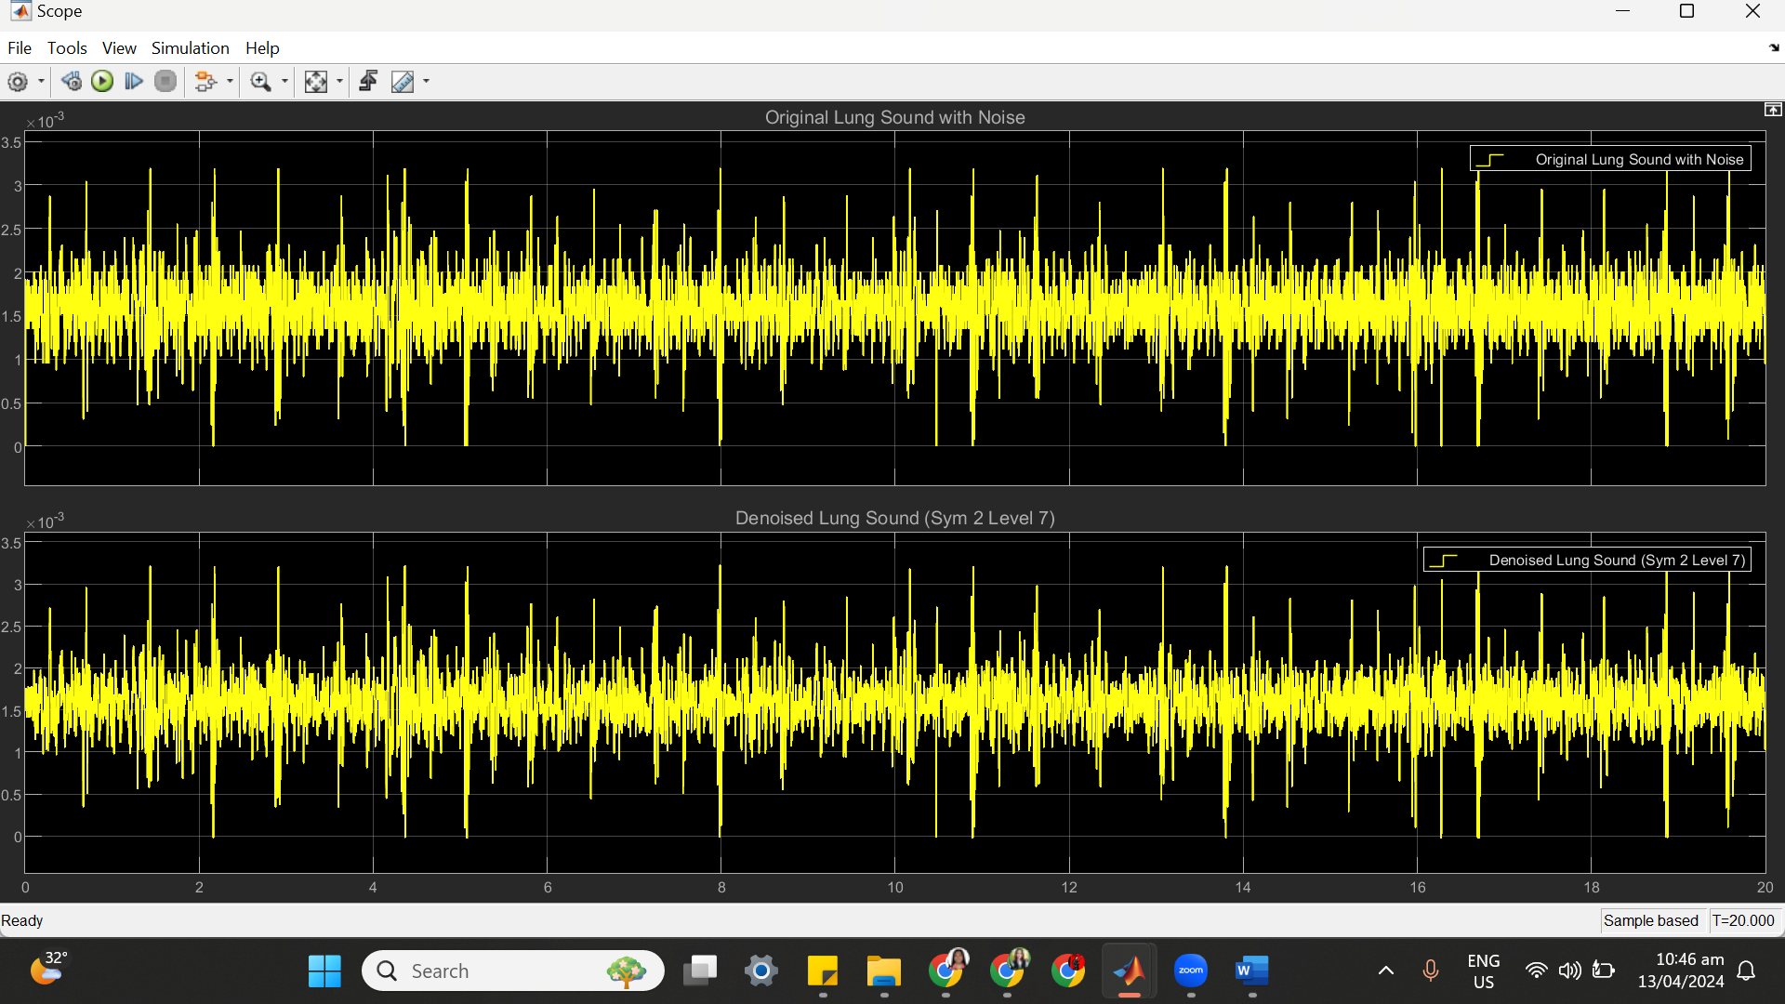

(c) SYM 2 LEVEL 7 STATISTICS RESULT

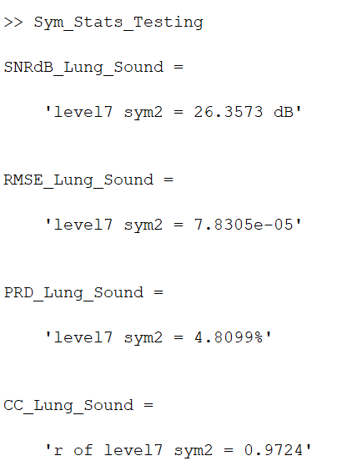

(d) SYM 2 LEVEL 7 SCATTER PLOT RESULT

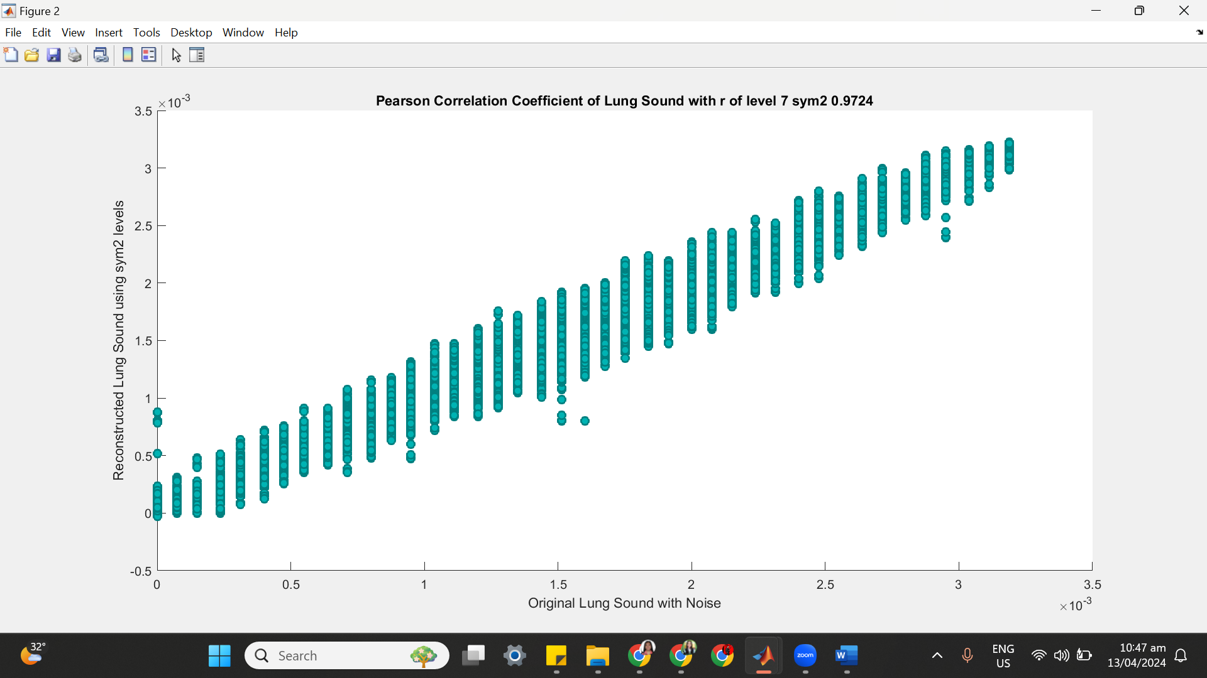

**=====================================================**

**SYM 3**

| **SYM 3** | **No of Delay** | **SNRdB_Lungs_Sound** | **RMSE_Lungs_Sound** | **PRD_Lungs_Sound** | **CC_Lungs**  **_Sound** |
| --- | --- | --- | --- | --- | --- |
| Level 2 | 41 | 24.6085 dB | 9.579e-05 | 5.8827% | 0.95841 |
| Level 3 | 74 | 24.7119 dB | 9.4632e-05 | 5.813% | 0.95955 |
| Level 4 | 125 | 25.9292 dB | 8.2274e-05 | 5.0529% | 0.96948 |
| Level 5 | 156 | 26.1162 dB | 8.0495e-05 | 4.9453% | 0.97075 |
| Level 6 | 187 | 26.2704 dB | 7.9087e-05 | 4.8583% | 0.97172 |
| Level 7 | 218 | 26.2886 dB | 7.8923e-05 | 4.8481% | 0.97191 |

**++++++++++++++++++++++++++++++++++++++++++++++++++++++++++++++++++**

**(1) SYM 3 LEVEL 2**

(a) SYM 3 LEVEL 2 ARCHITECTURE

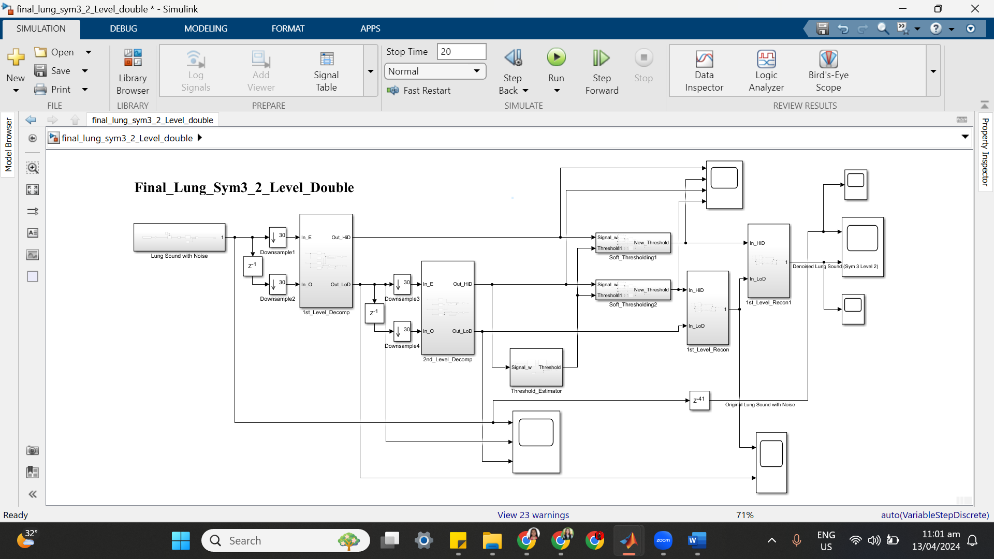

(b) SYM 3 LEVEL 2 SIMULATION RESULT

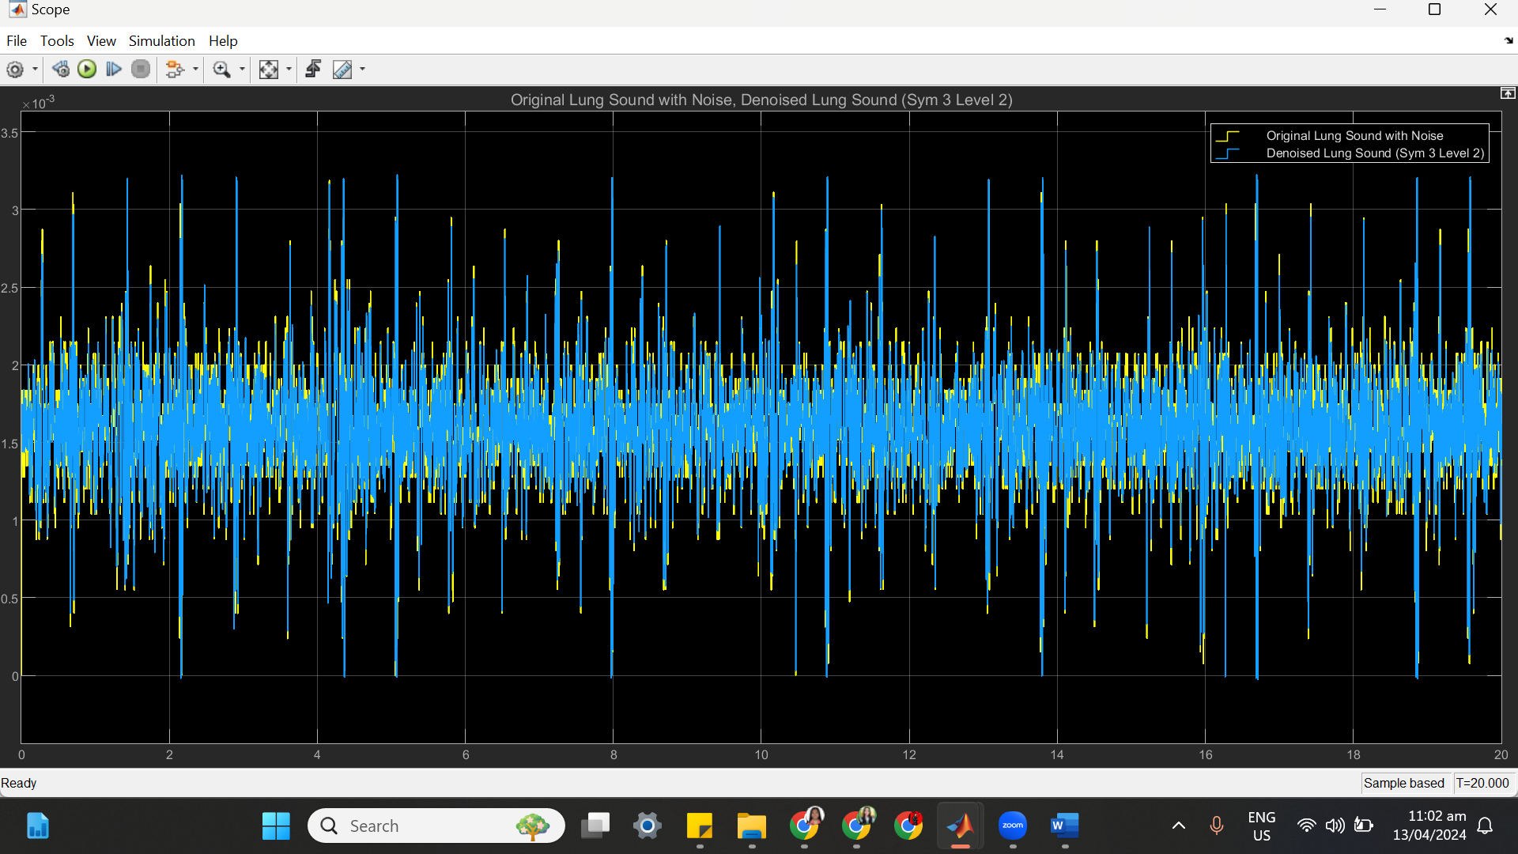

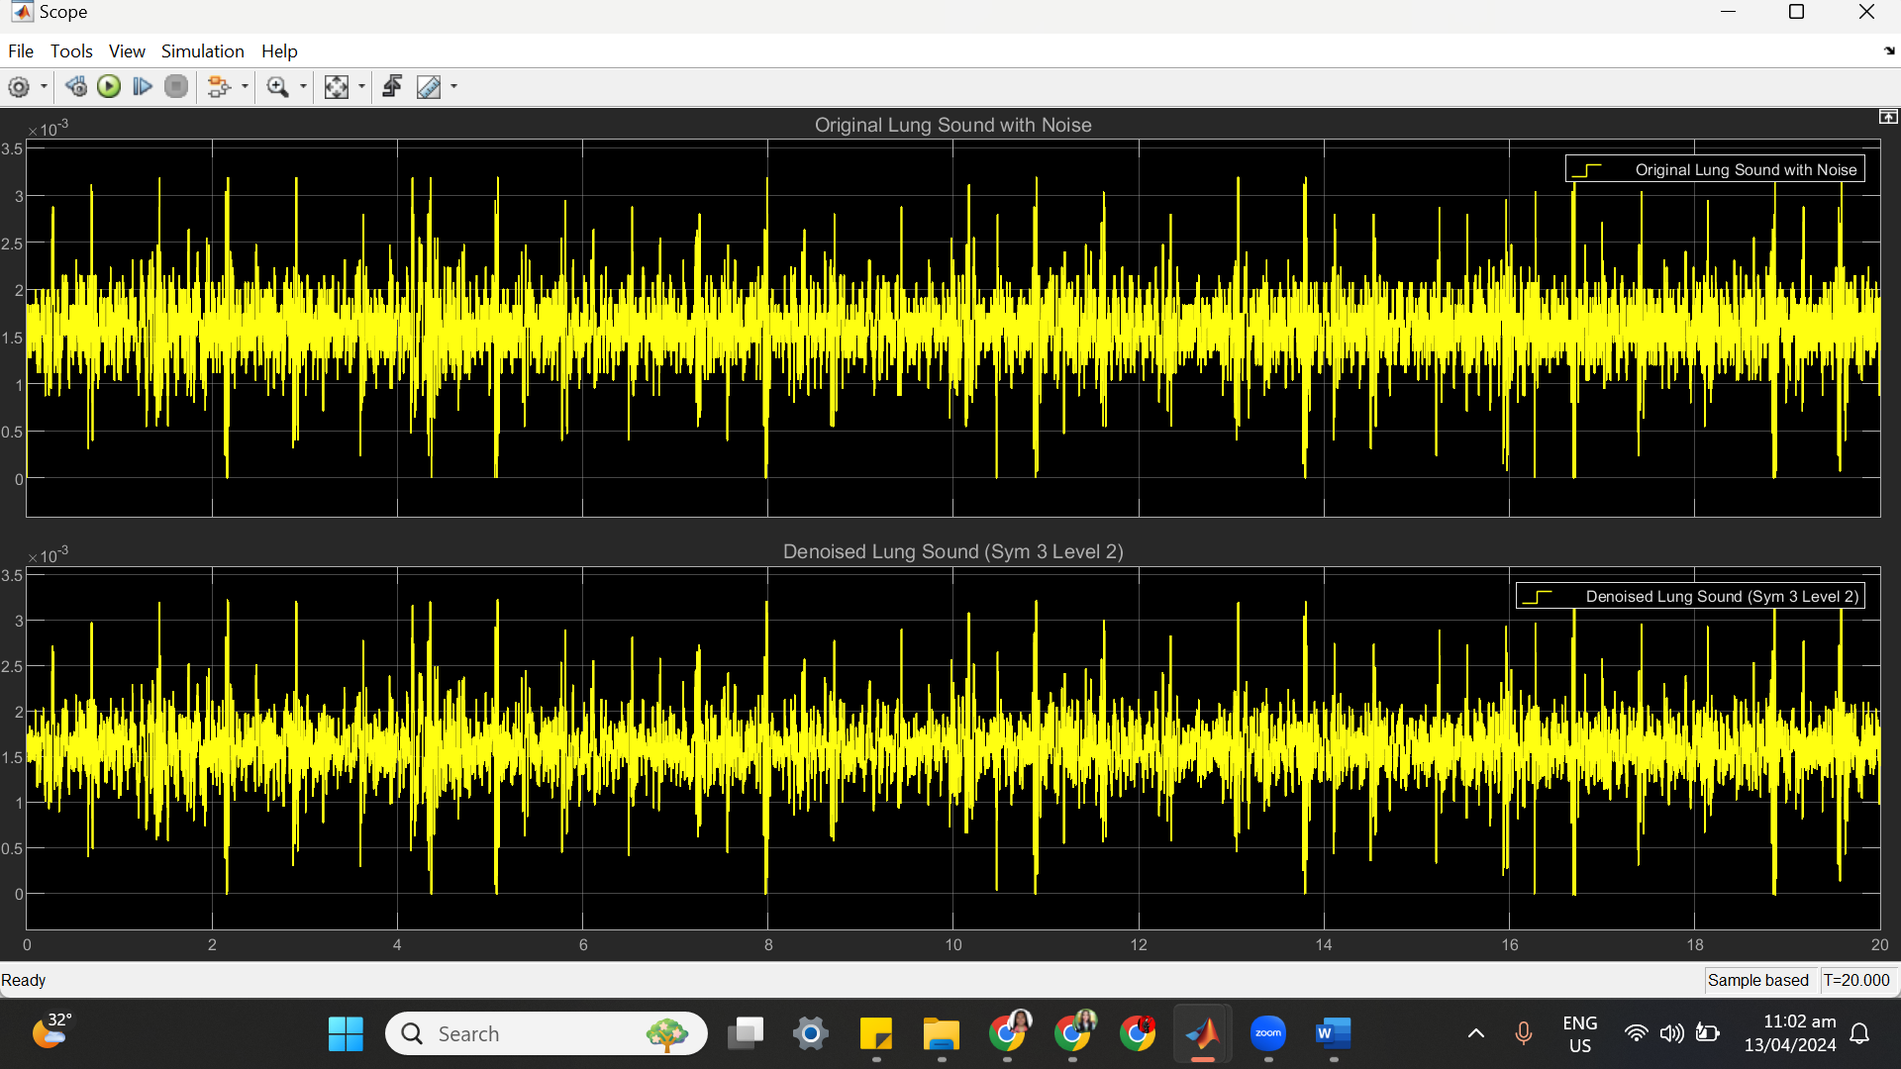

(c) SYM 3 LEVEL 2 STATISTICS RESULT

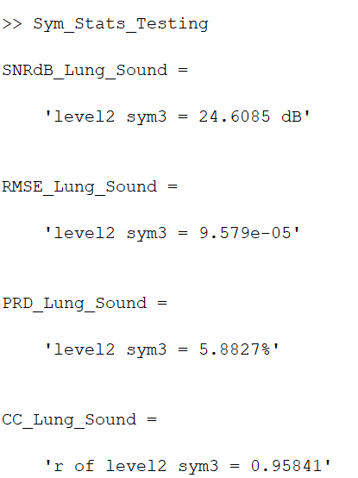

(d) SYM 3 LEVEL 2 SCATTER PLOT RESULT

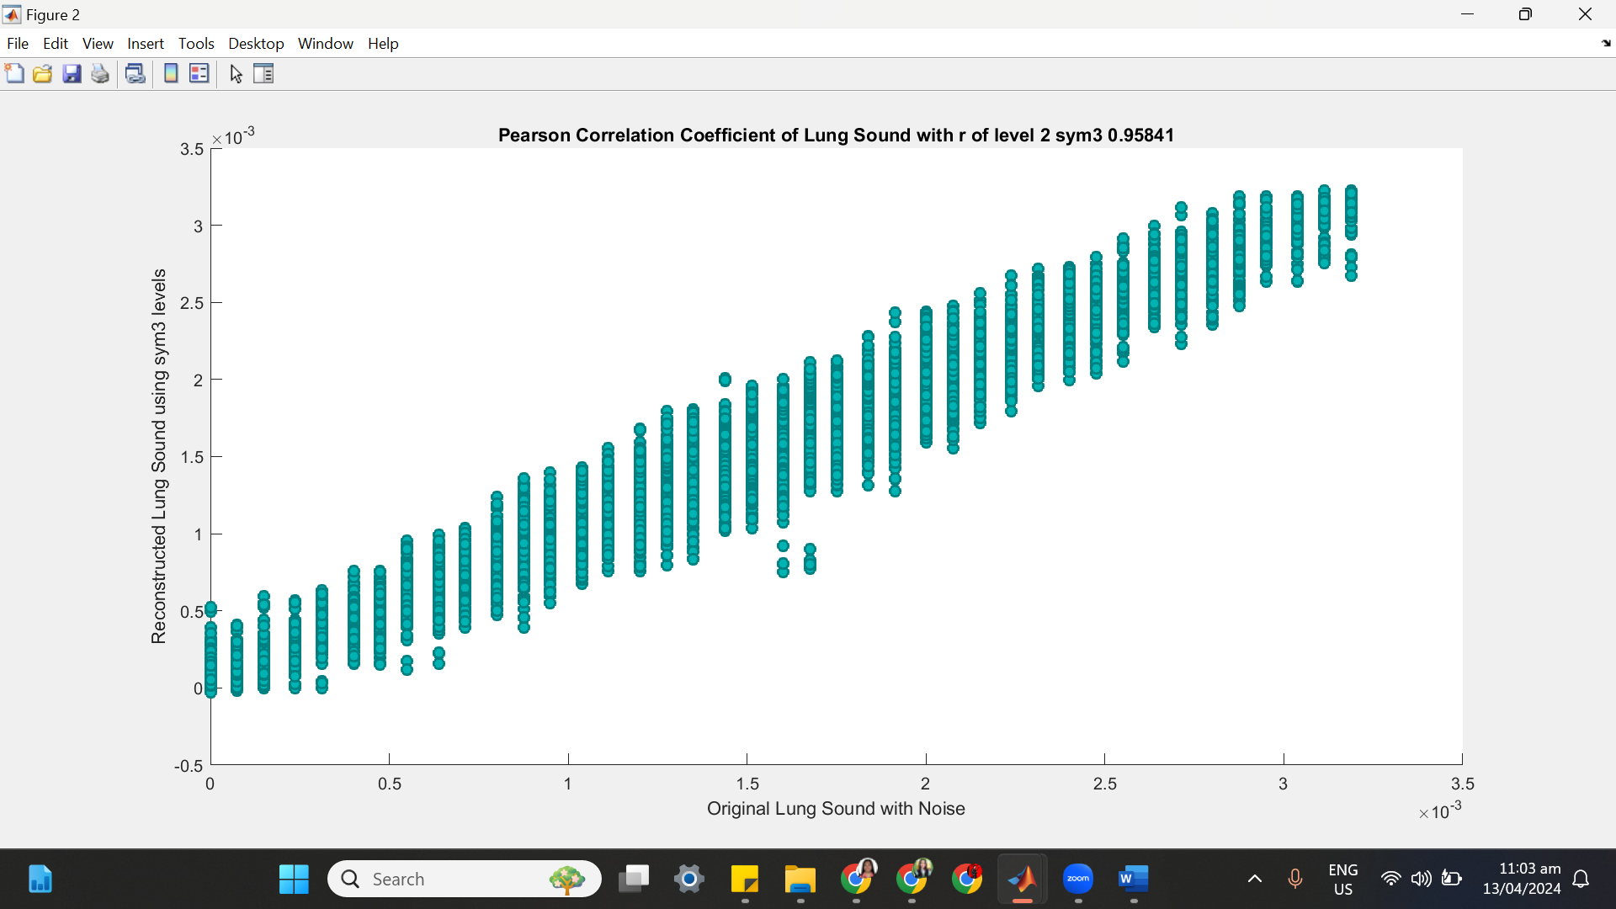

**++++++++++++++++++++++++++++++++++++++++++++++++++++++++++++++++++**

**(2) SYM 3 LEVEL 3**

(a) SYM 3 LEVEL 3 ARCHITECTURE

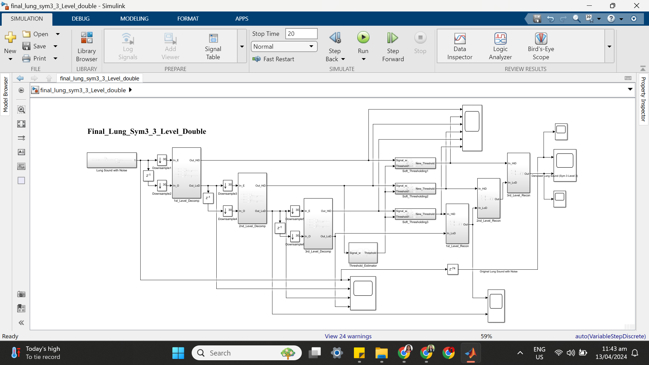

(b) SYM 3 LEVEL 3 SIMULATION RESULT

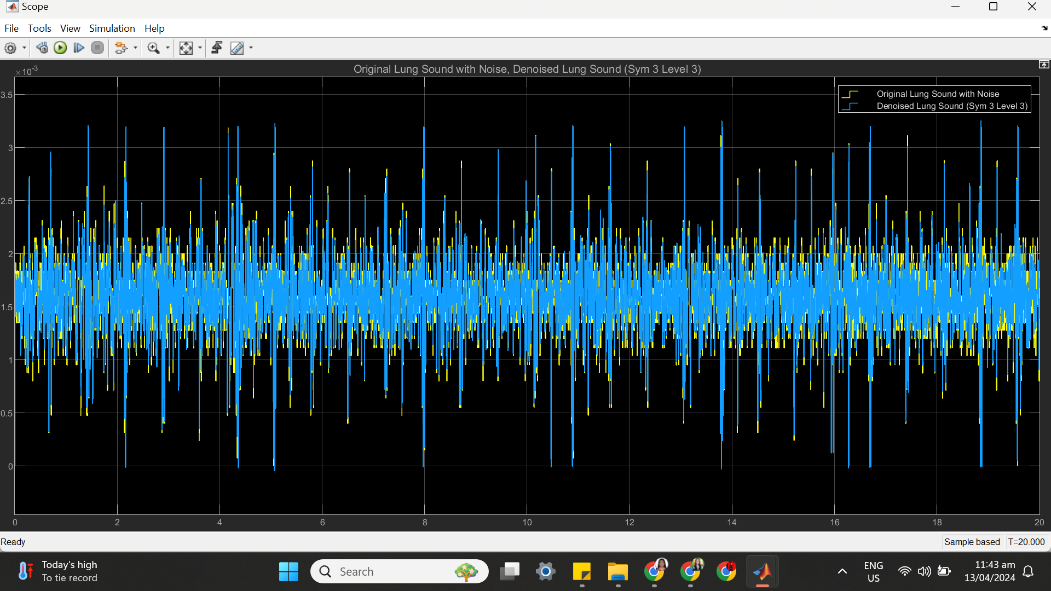

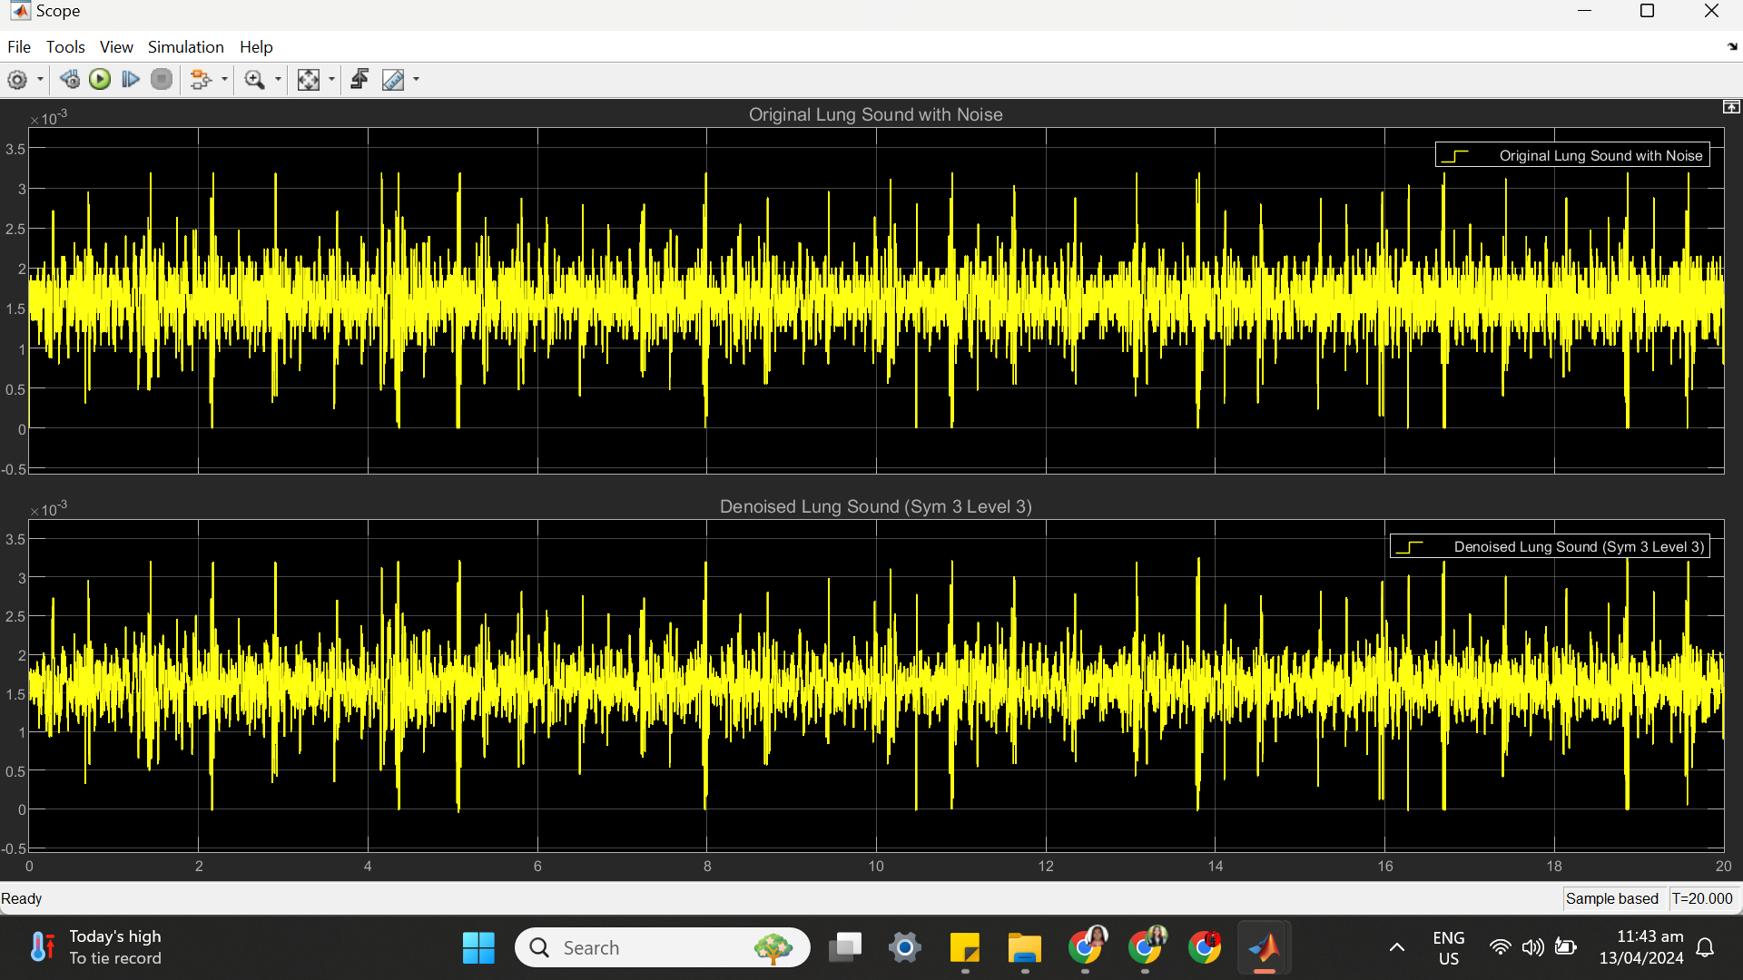

(c) SYM 3 LEVEL 3 STATISTICS RESULT

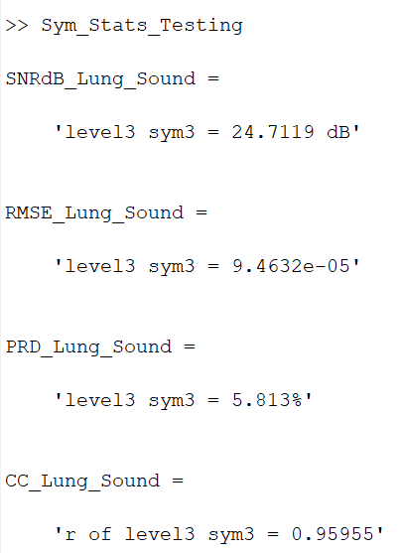

(d) SYM 3 LEVEL 3 SCATTER PLOT RESULT

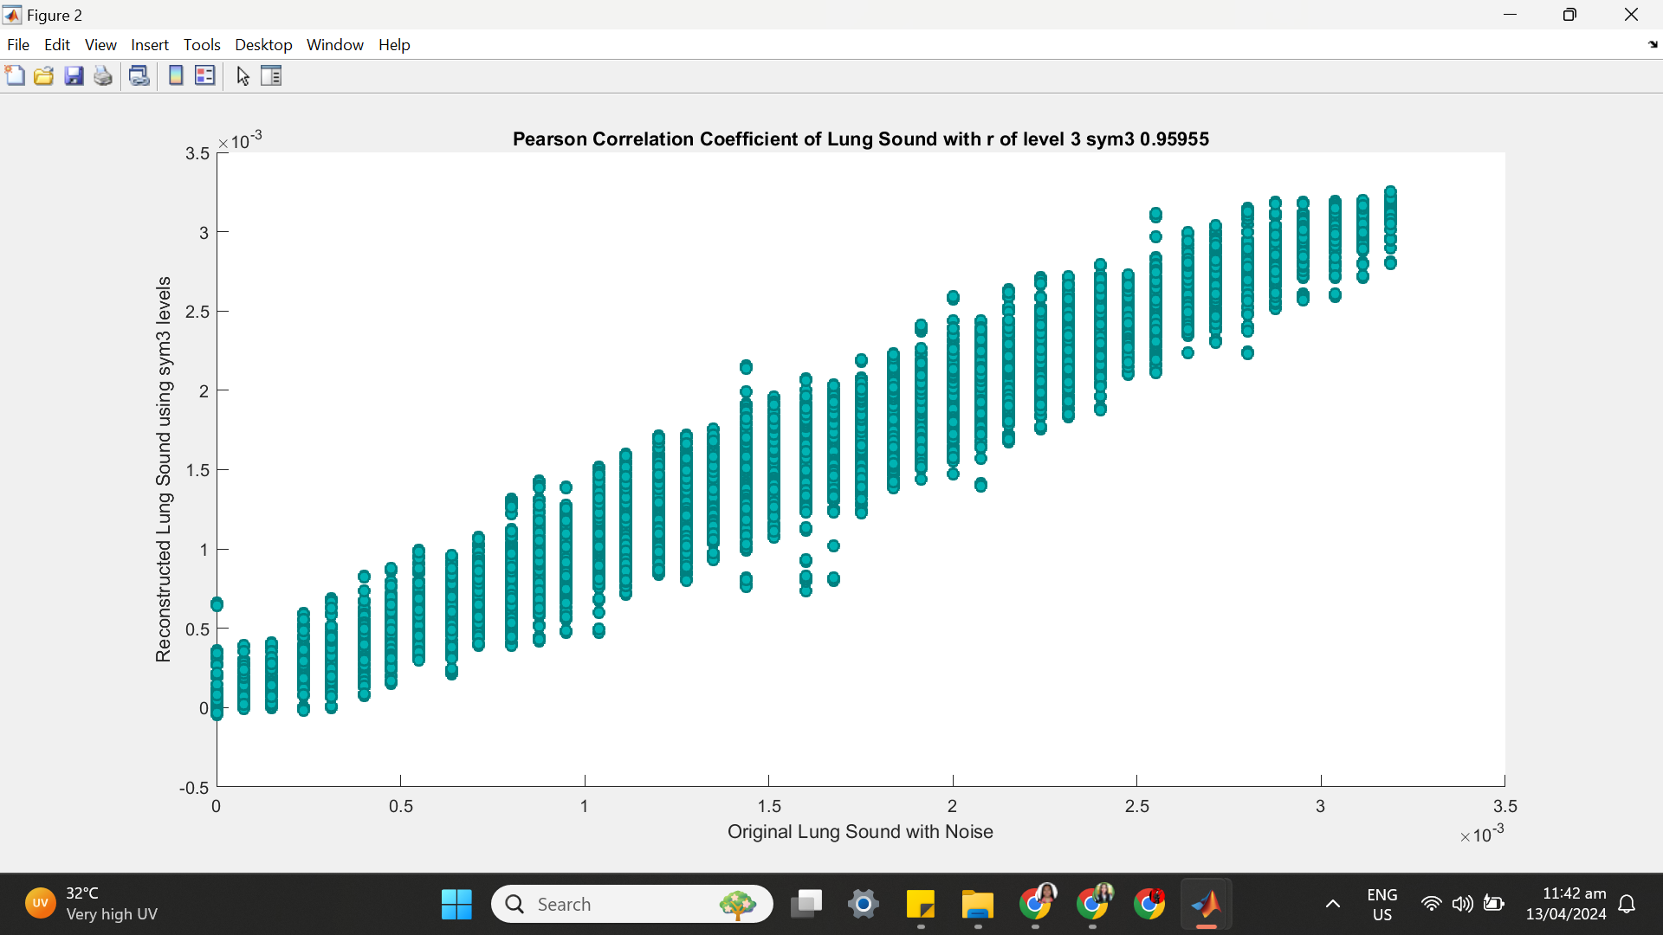

**++++++++++++++++++++++++++++++++++++++++++++++++++++++++++++++++++**

**(3) SYM 3 LEVEL 4**

(a) SYM 3 LEVEL 4 ARCHITECTURE

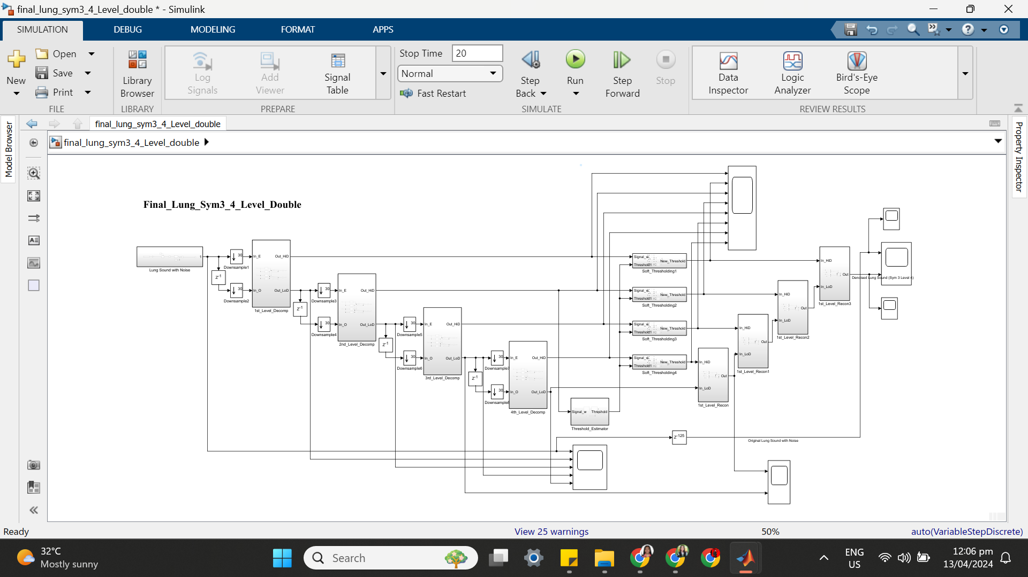

(b) SYM 3 LEVEL 4 SIMULATION RESULT

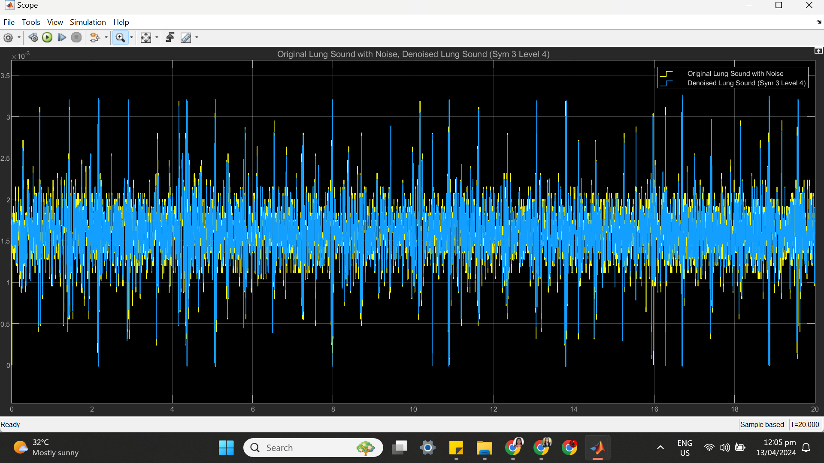

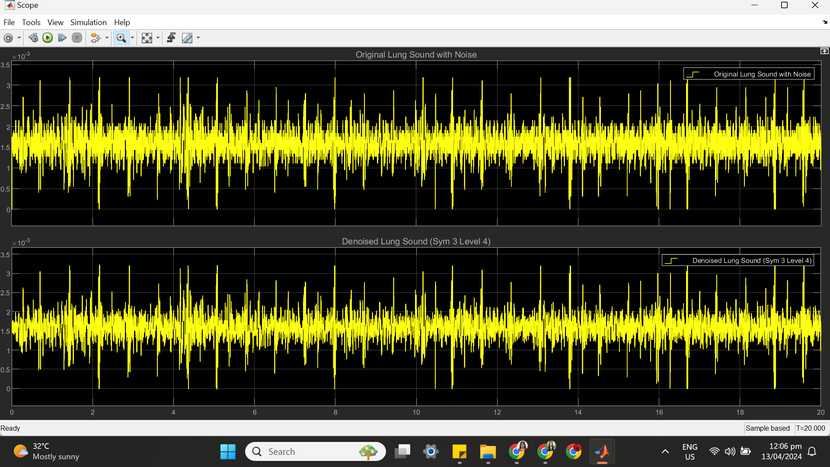

(c) SYM 3 LEVEL 4 STATISTICS RESULT

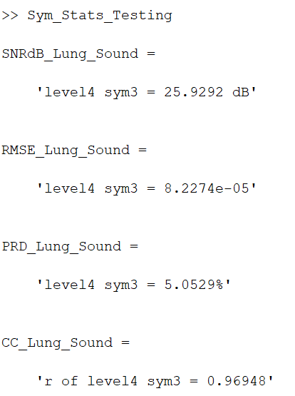

(d) SYM 3 LEVEL 4 SCATTER PLOT RESULT

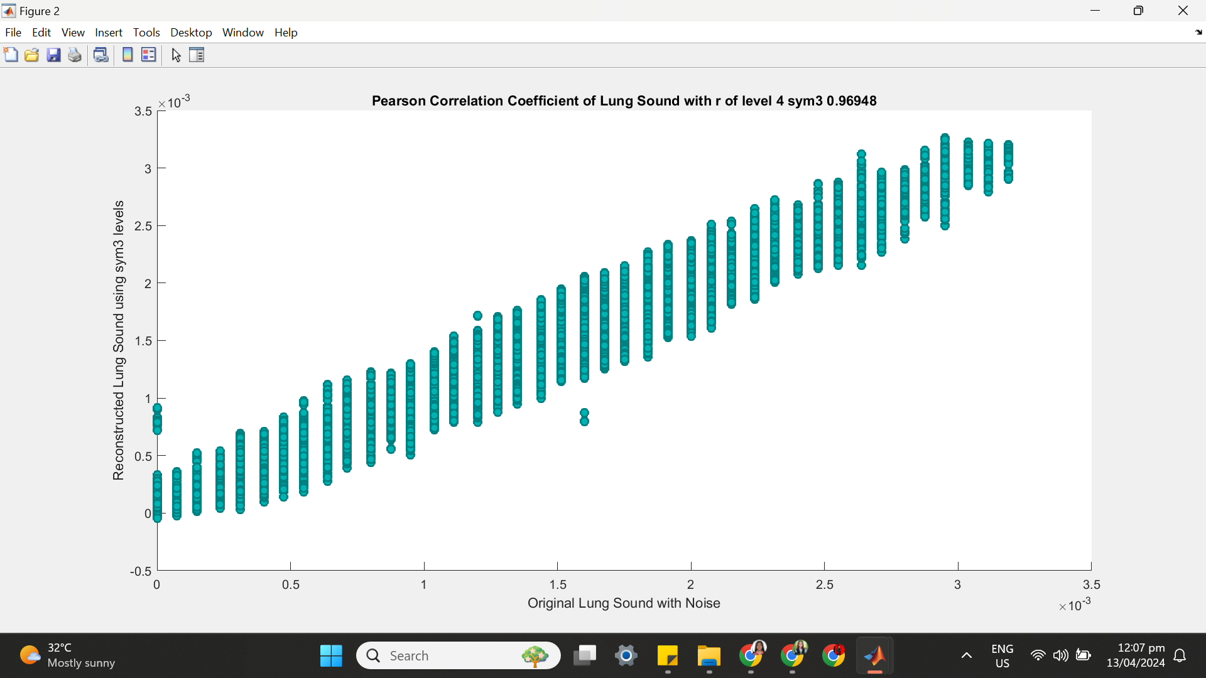

**++++++++++++++++++++++++++++++++++++++++++++++++++++++++++++++++++**

**(4) SYM 3 LEVEL 5**

(a) SYM 3 LEVEL 5 ARCHITECTURE

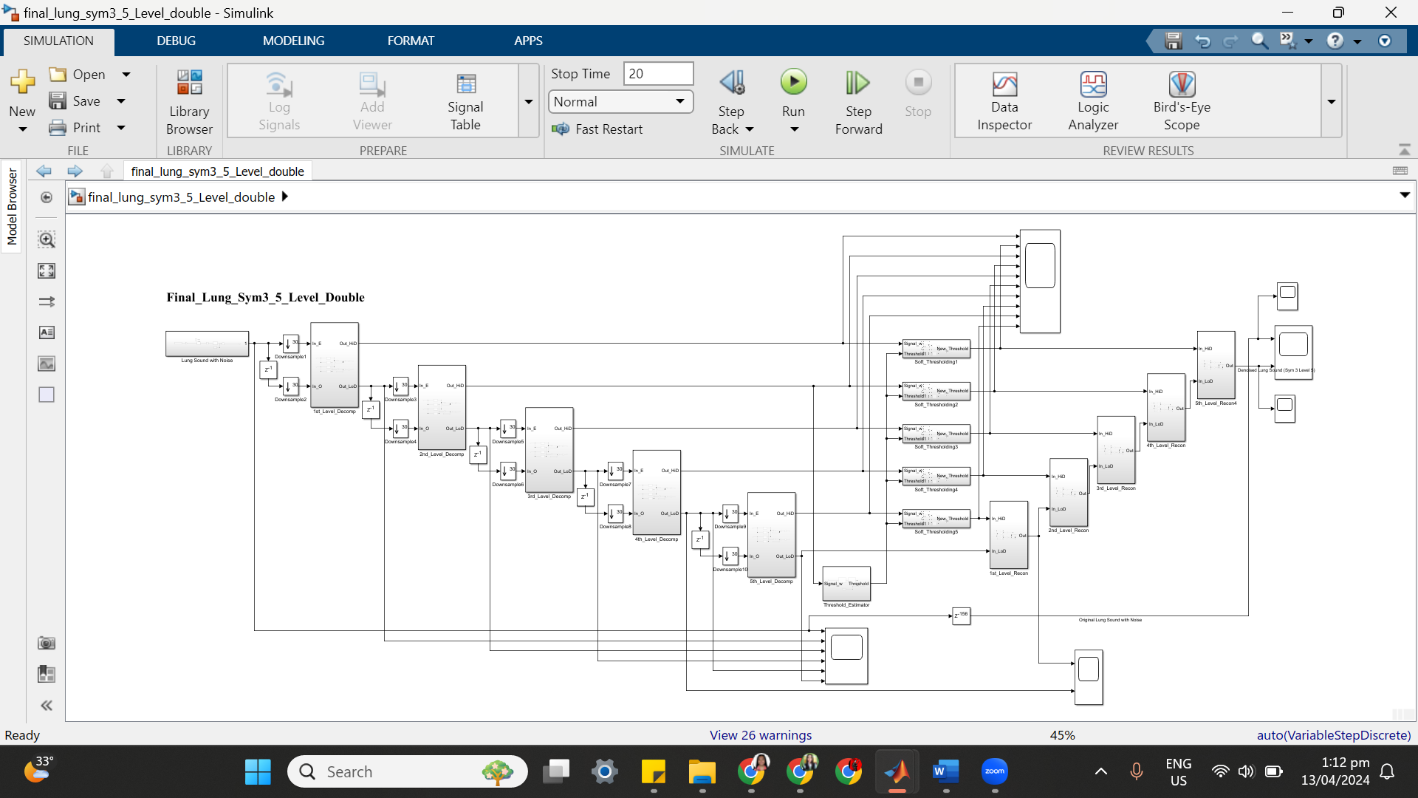

(b) SYM 3 LEVEL 5 SIMULATION RESULT

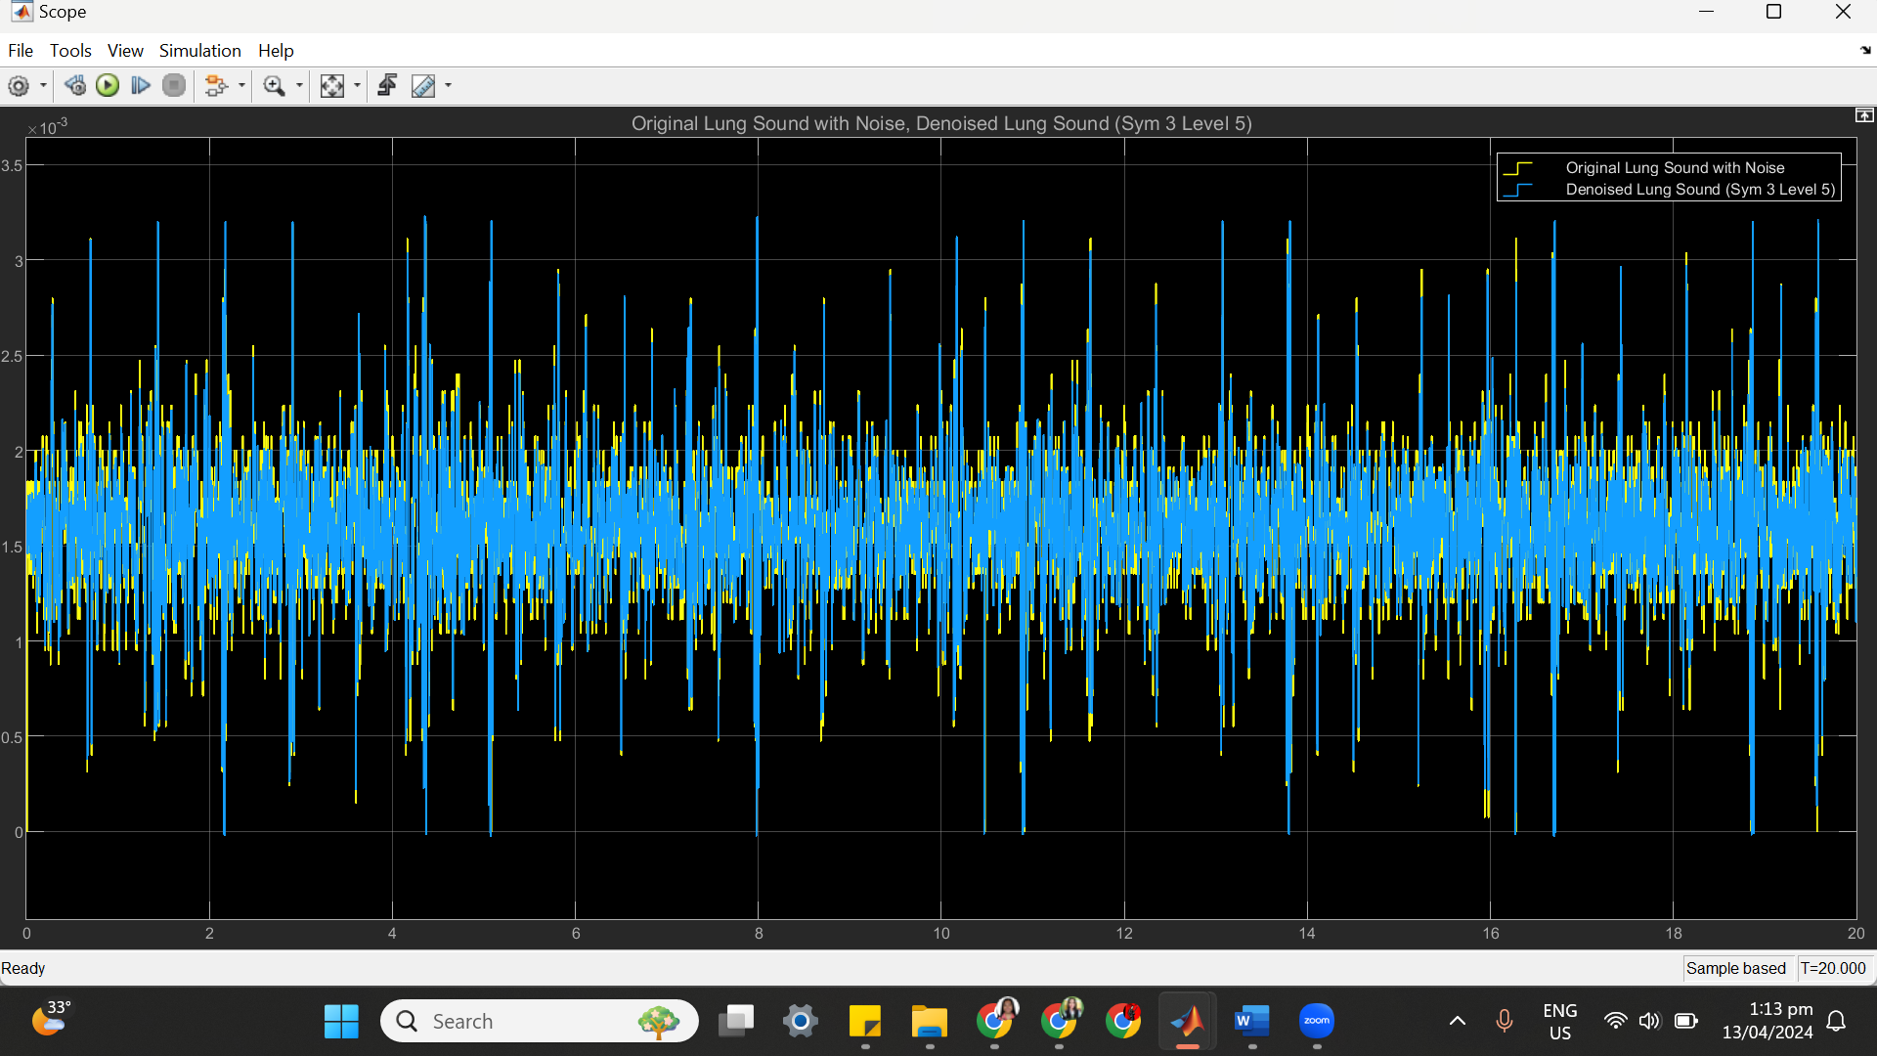

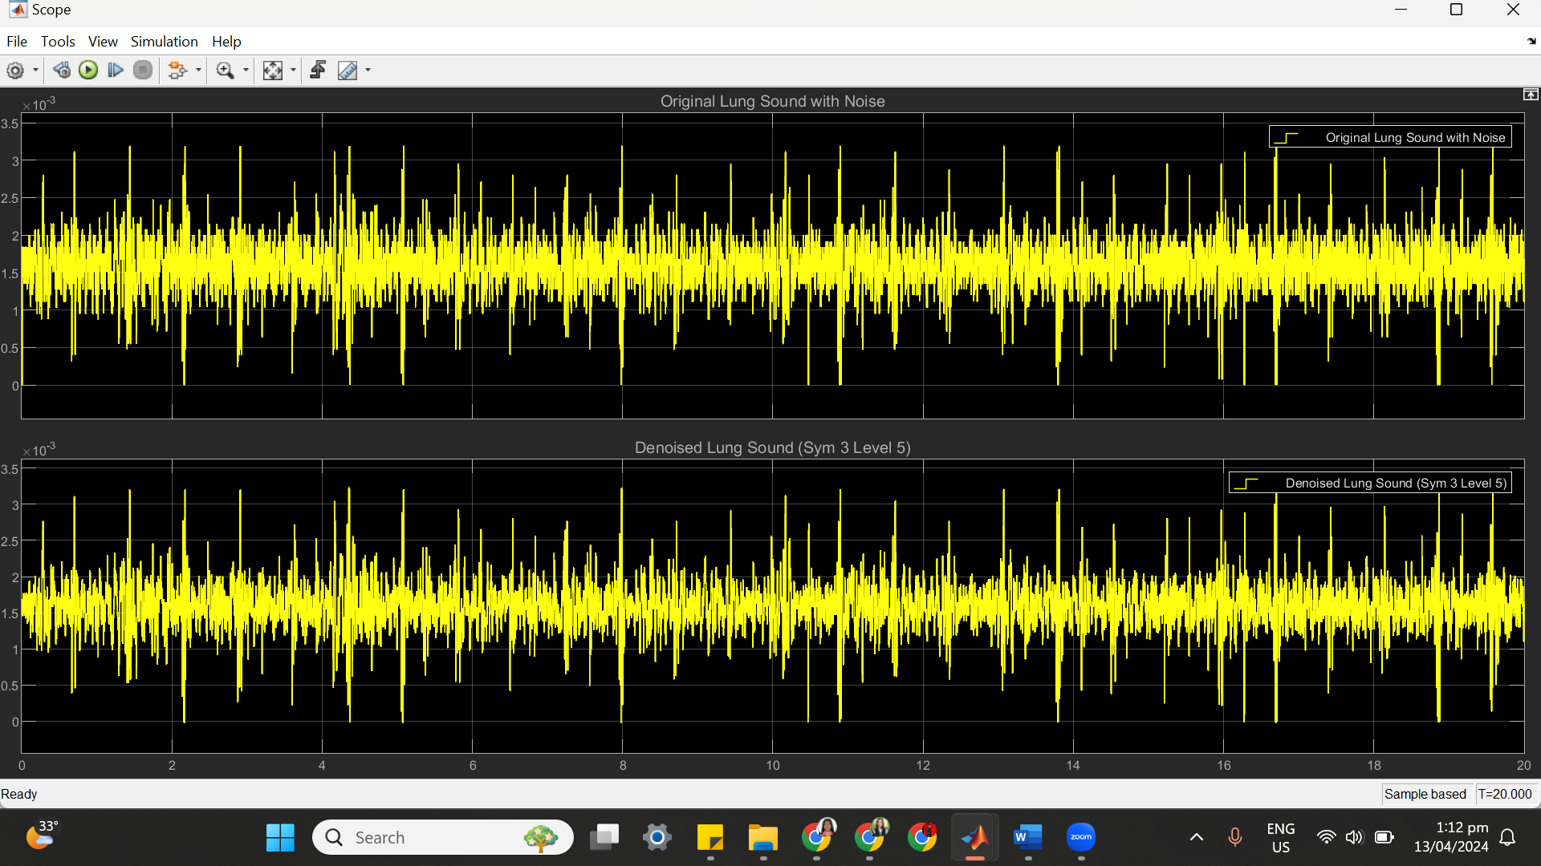

(c) SYM 3 LEVEL 5 STATISTICS RESULT

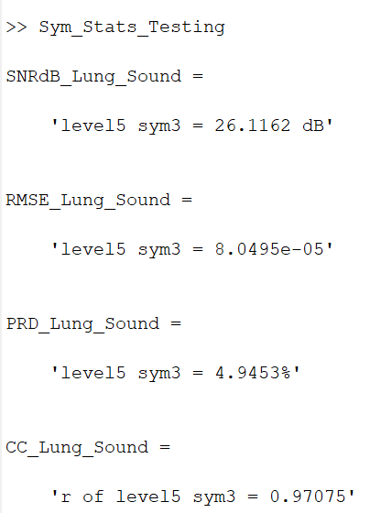

(d) SYM 3 LEVEL 5 SCATTER PLOT RESULT

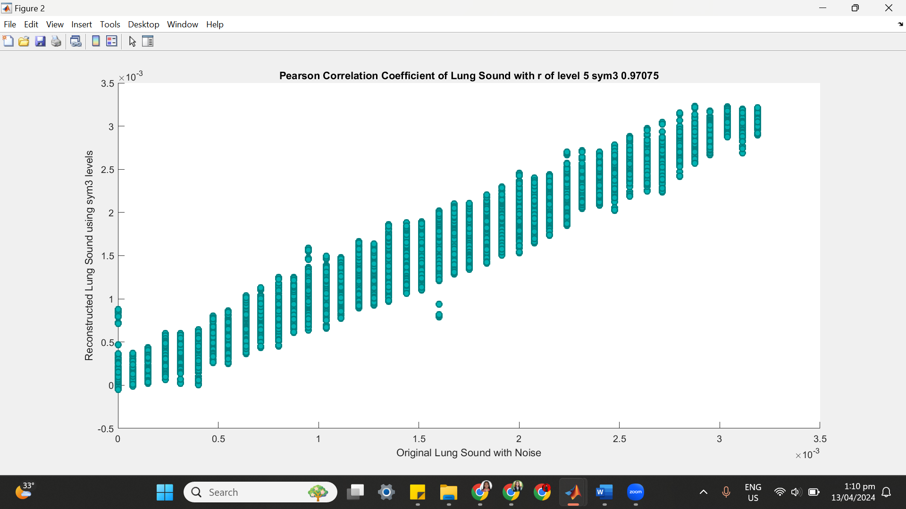

**++++++++++++++++++++++++++++++++++++++++++++++++++++++++++++++++++**

**(5) SYM 3 LEVEL 6**

(a) SYM 3 LEVEL 6 ARCHITECTURE

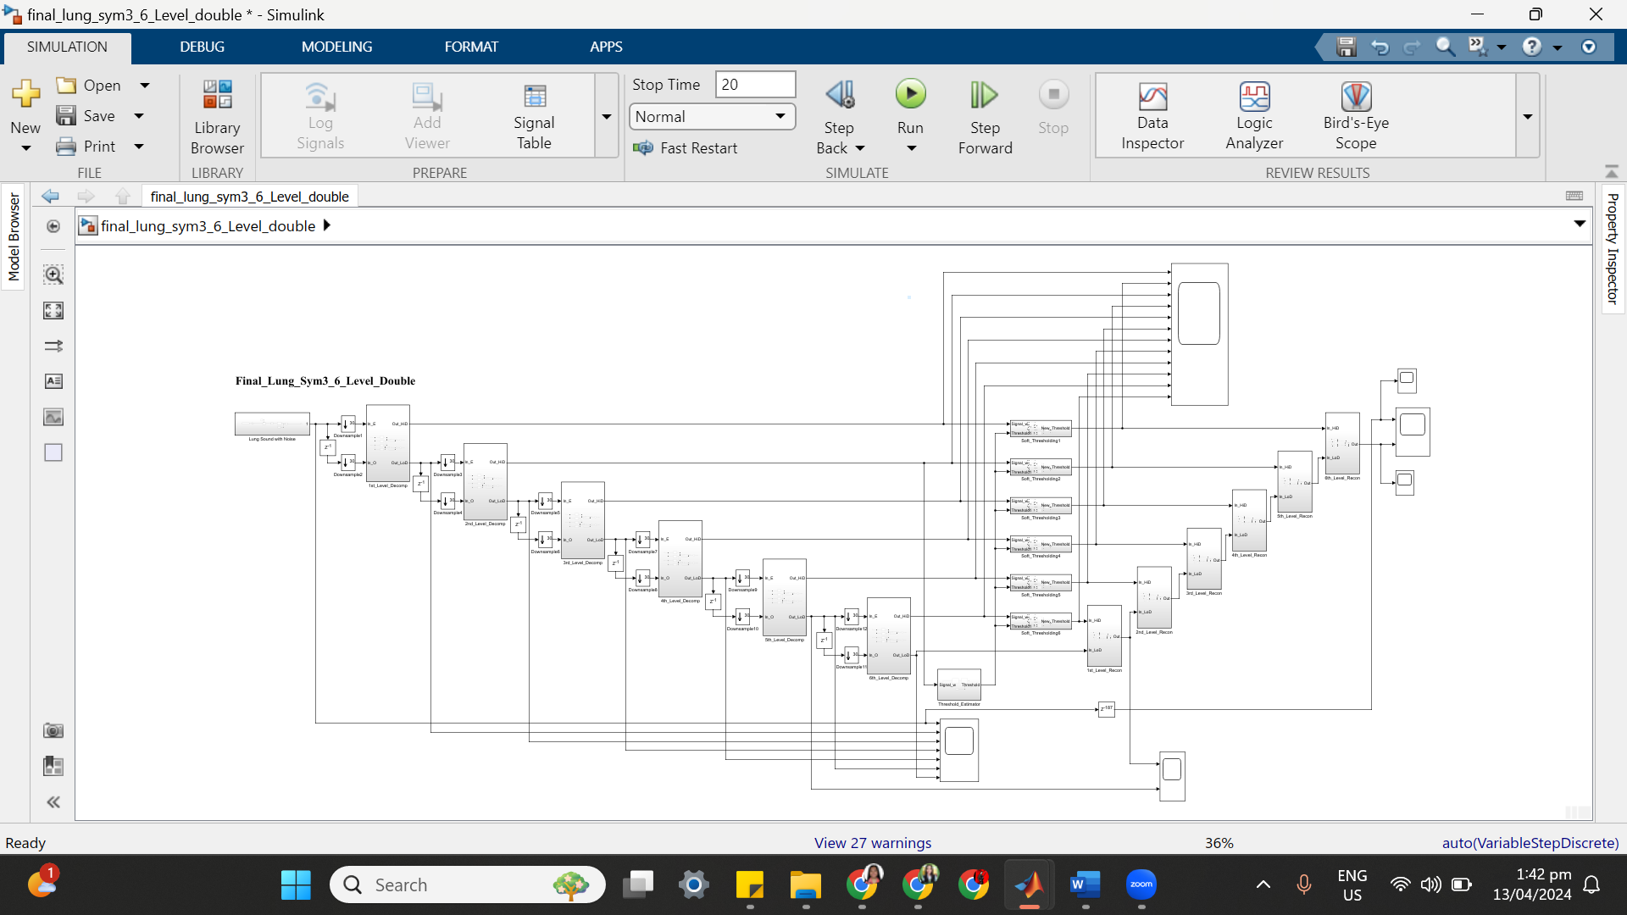

(b) SYM 3 LEVEL 6 SIMULATION RESULT

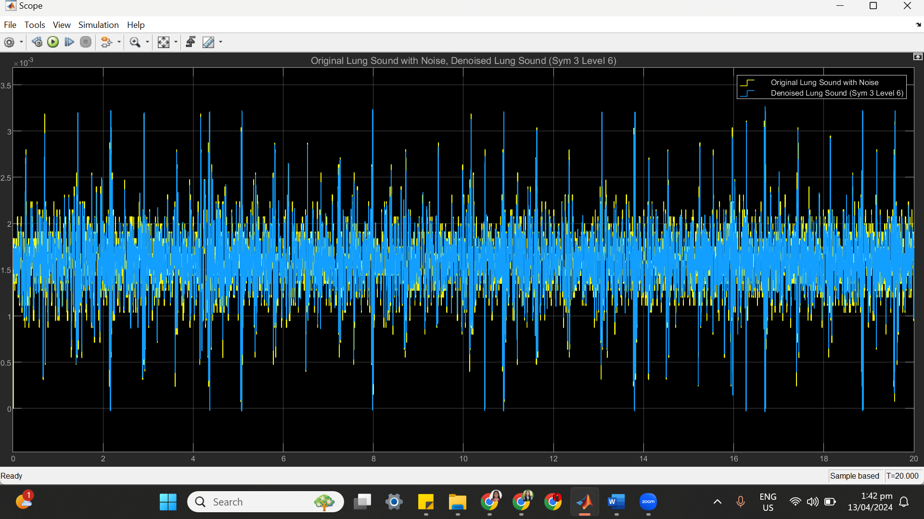

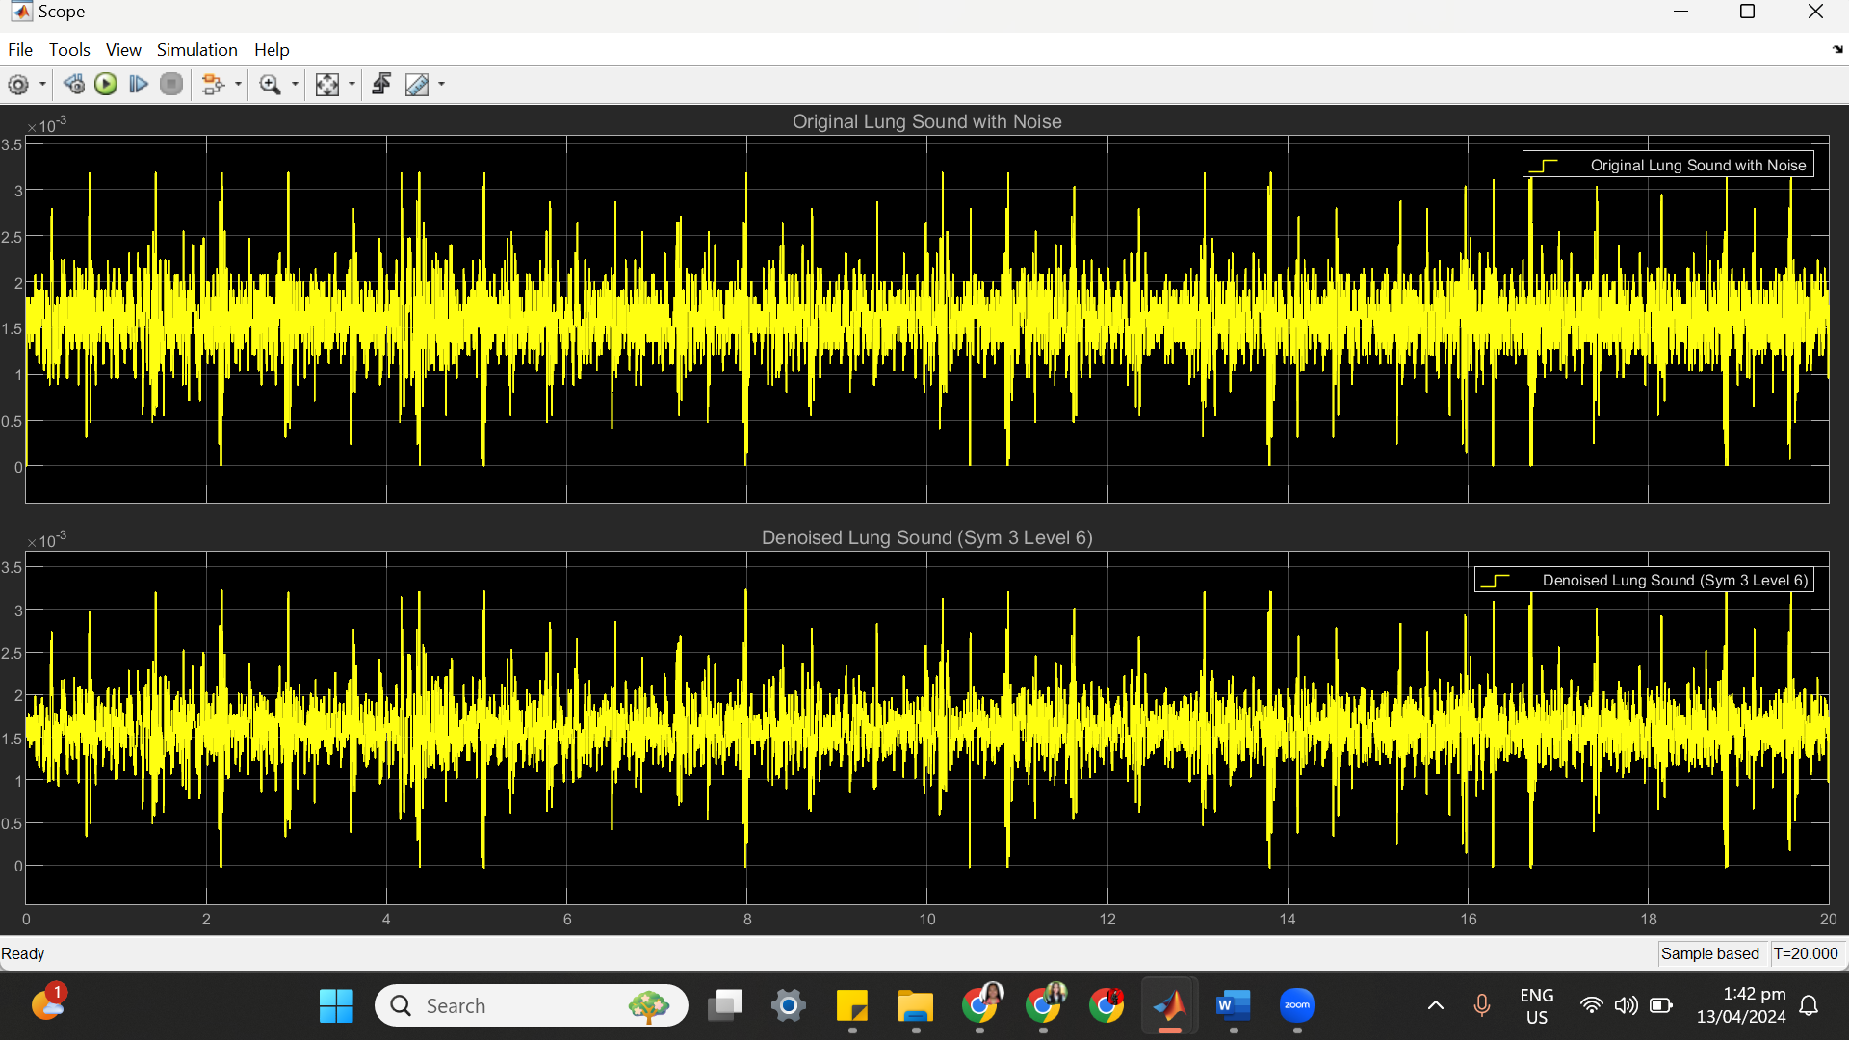

(c) SYM 3 LEVEL 6 STATISTICS RESULT

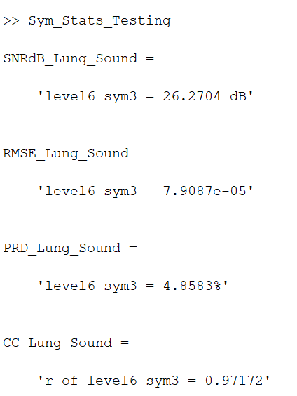

(d) SYM 3 LEVEL 6 SCATTER PLOT RESULT

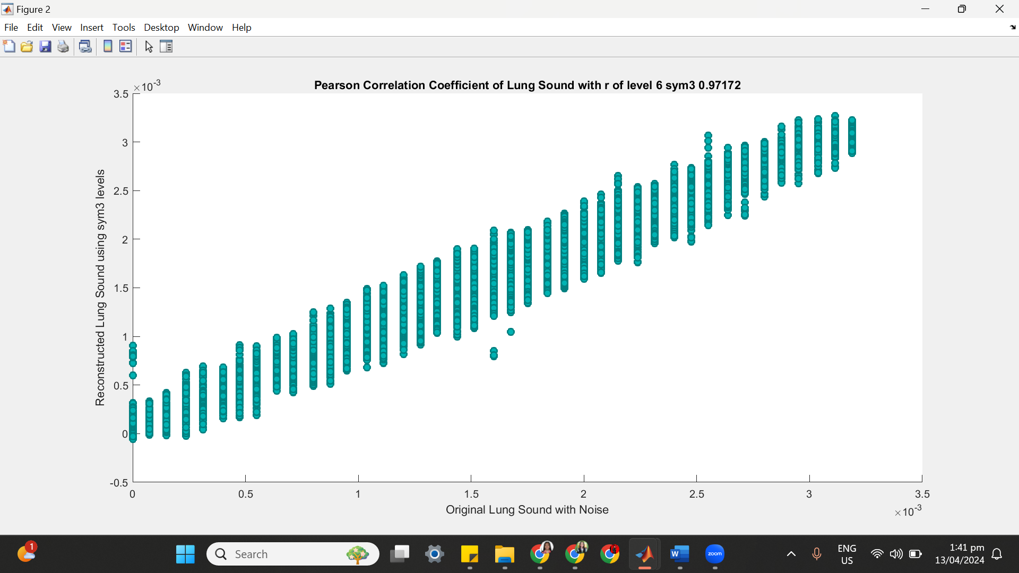

**++++++++++++++++++++++++++++++++++++++++++++++++++++++++++++++++++**

**(6) SYM 3 LEVEL 7**

(a) SYM 3 LEVEL 7 ARCHITECTURE

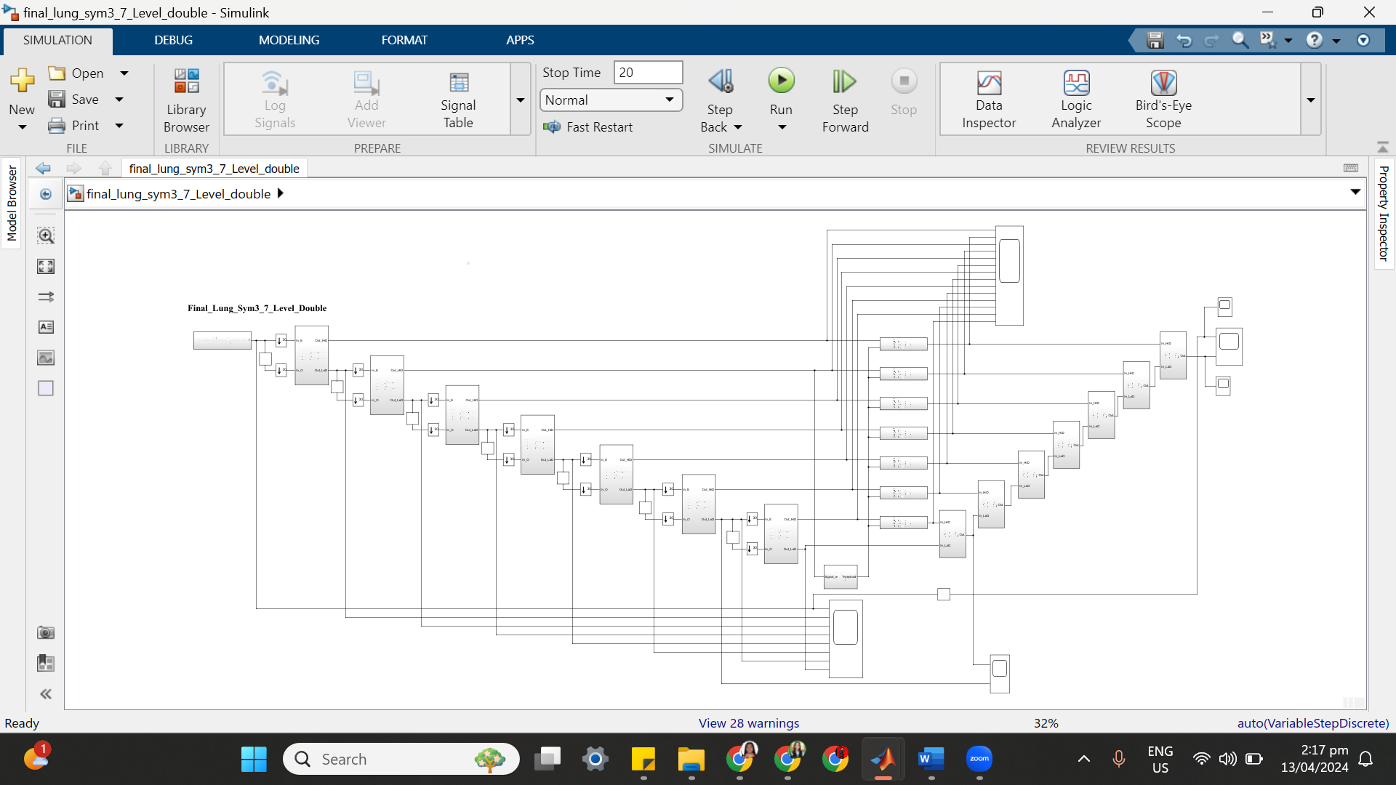

(b) SYM 3 LEVEL 7 SIMULATION RESULT

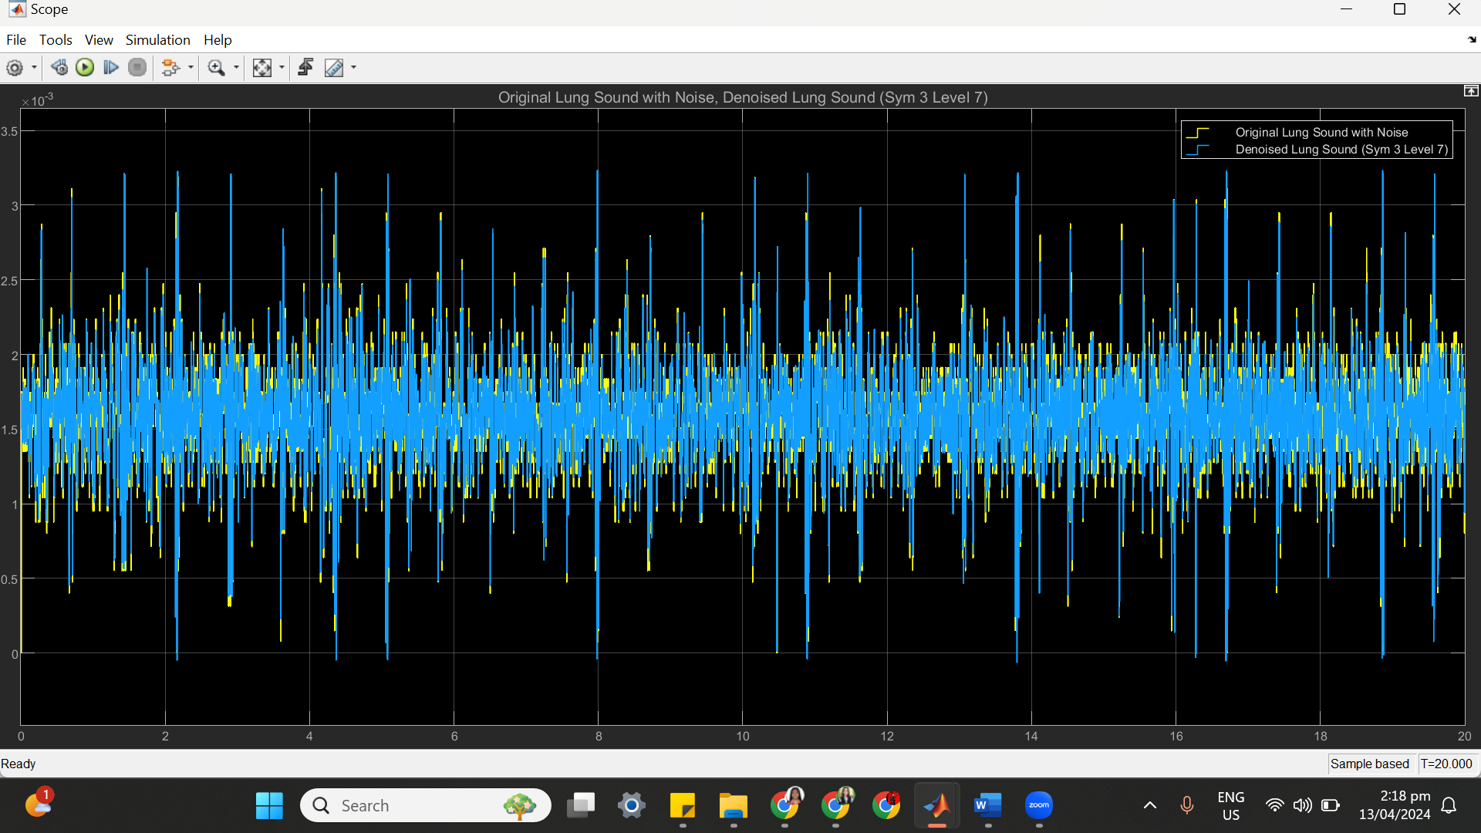

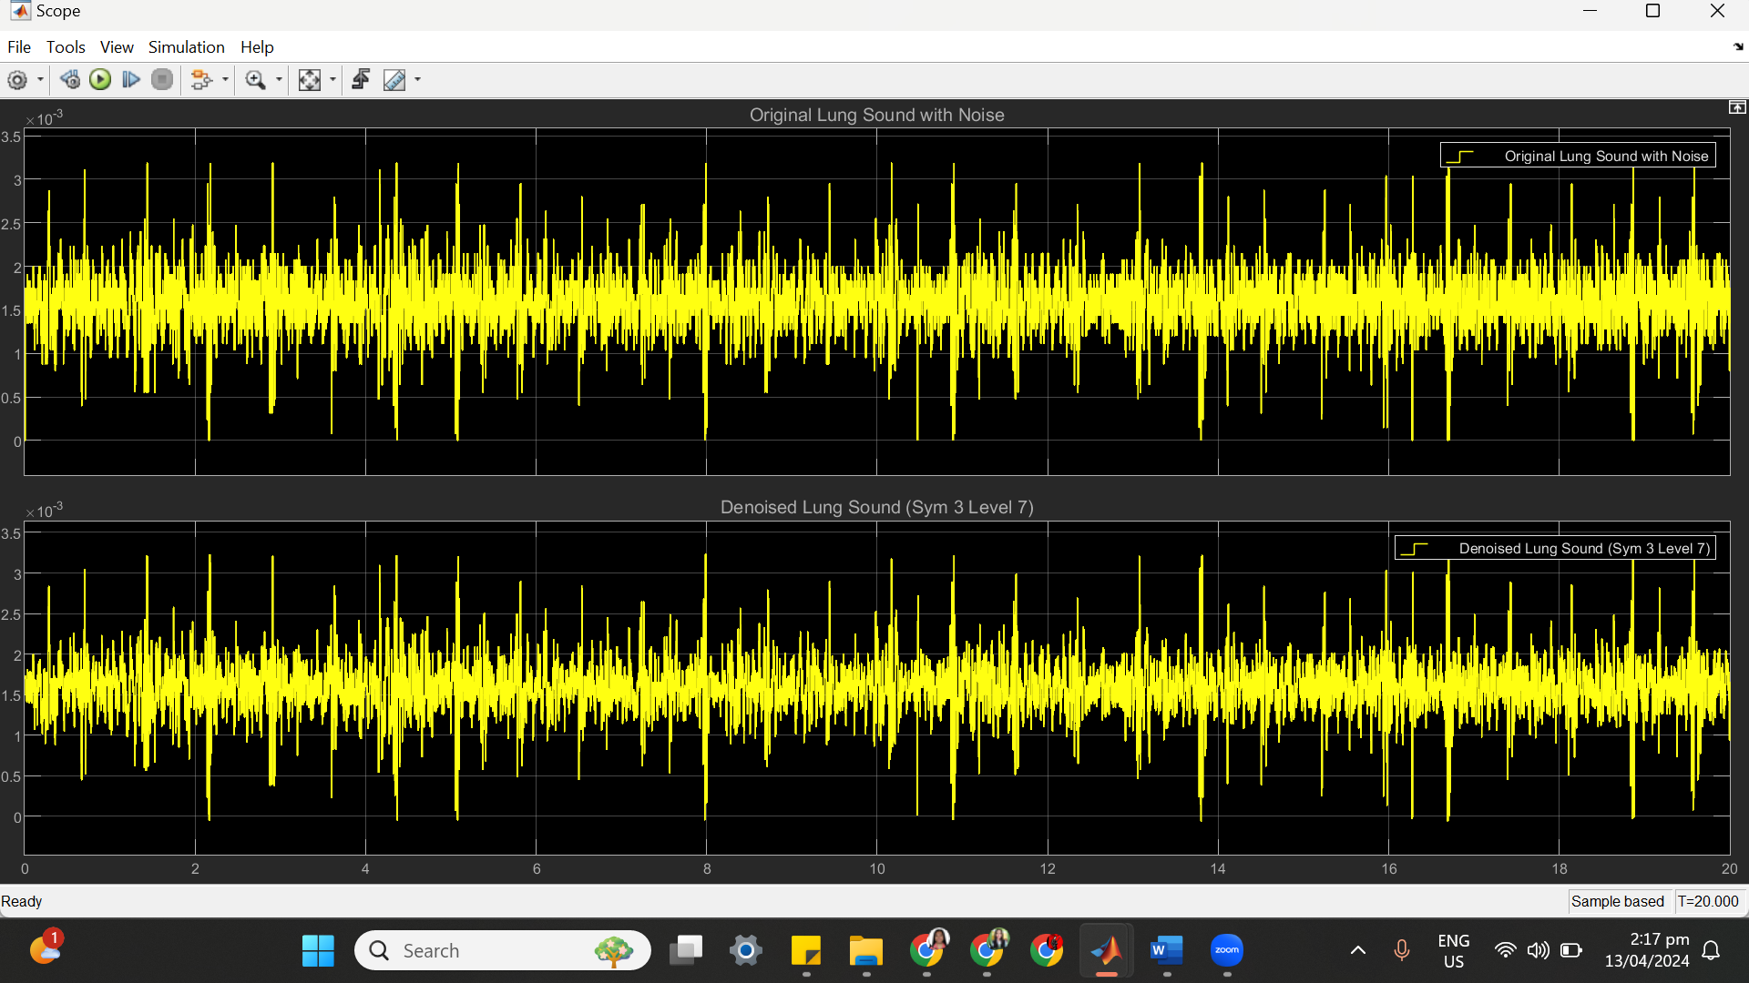

(c) SYM 3 LEVEL 7 STATISTICS RESULT

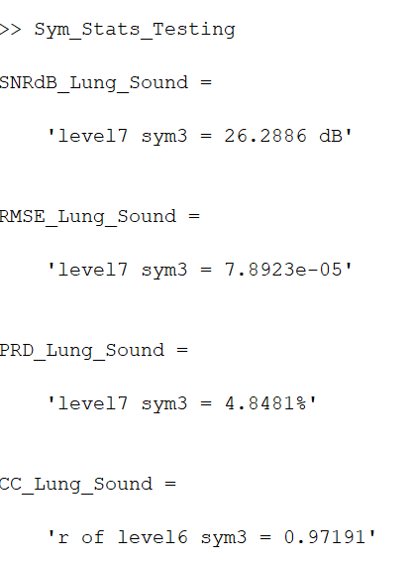

(d) SYM 3 LEVEL 7 SCATTER PLOT RESULT

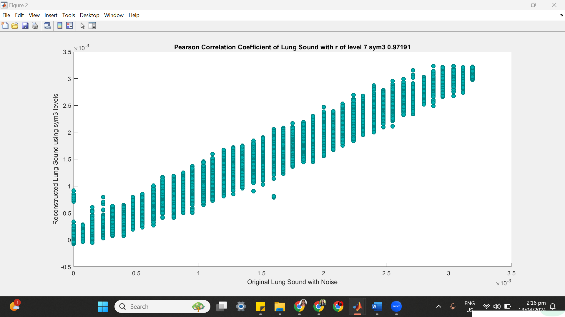

**=====================================================**

**SYM 4**

| **SYM 4** | **No of Delay** | **SNRdB_Lungs_Sound** | **RMSE_Lungs_Sound** | **PRD_Lungs_Sound** | **CC_Lungs**  **_Sound** |
| --- | --- | --- | --- | --- | --- |
| Level 2 | 43 | 24.0437 dB | 0.0001022 | 6.2779% | 0.95266 |
| Level 3 | 80 | 24.3743 dB | 9.8404e-05 | 6.0435% | 0.95613 |
| Level 4 | 117 | 24.605 dB | 9.5825e-05 | 5.885% | 0.95845 |
| Level 5 | 154 | 24.8484 dB | 9.3153e-05 | 5.7224% | 0.96088 |
| Level 6 | 188 | 25.0384 dB | 9.1156e-05 | 5.5986% | 0.96257 |
| Level 7 | 234 | 26.3013 dB | 7.8794e-05 | 4.841% | 0.97203 |

**++++++++++++++++++++++++++++++++++++++++++++++++++++++++++++++++++**

**(1) SYM 4 LEVEL 2**

(a) SYM 4 LEVEL 2 ARCHITECTURE

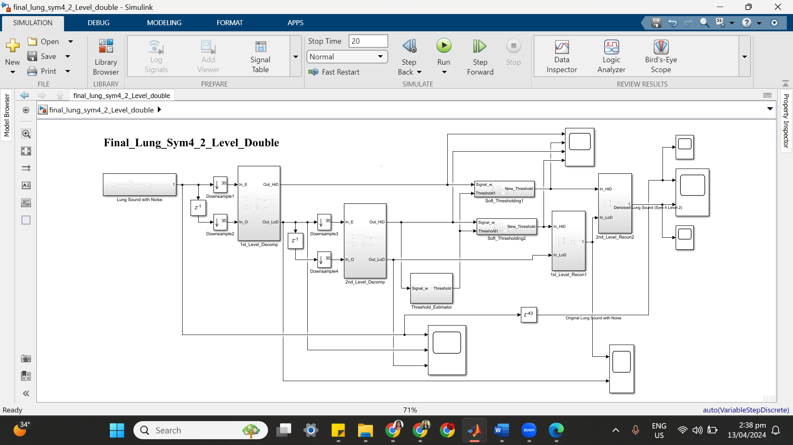

(b) SYM 4 LEVEL 2 SIMULATION RESULT

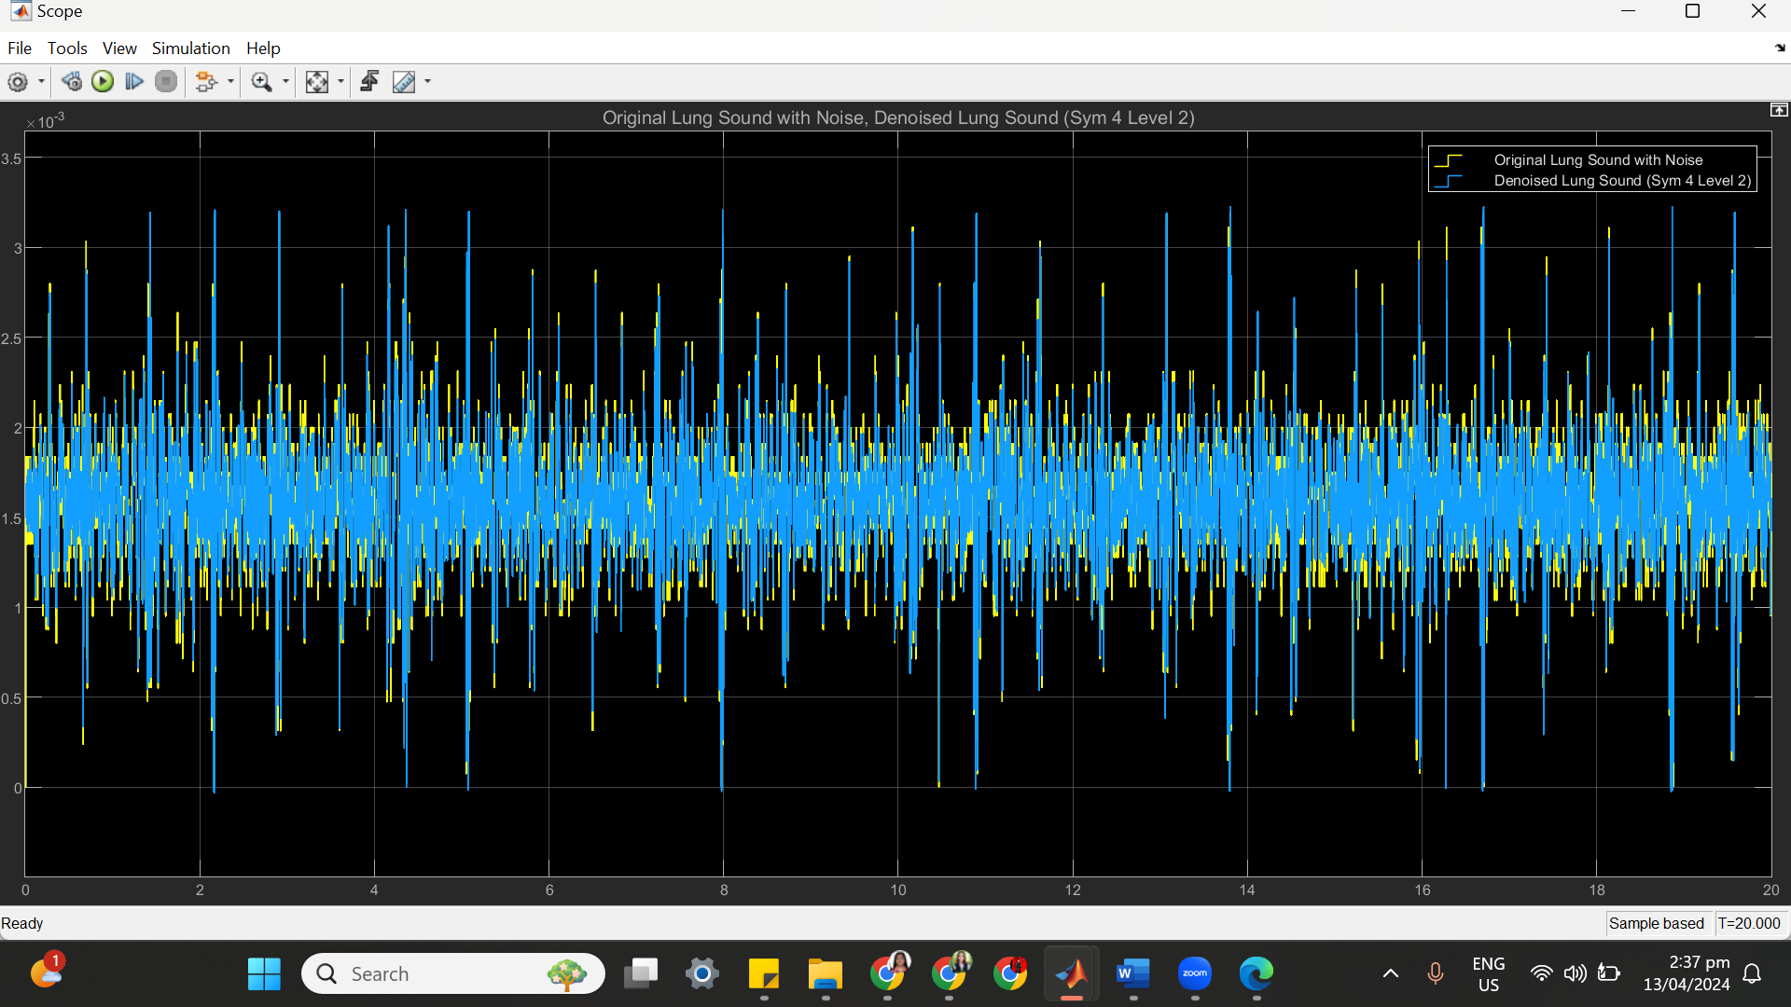

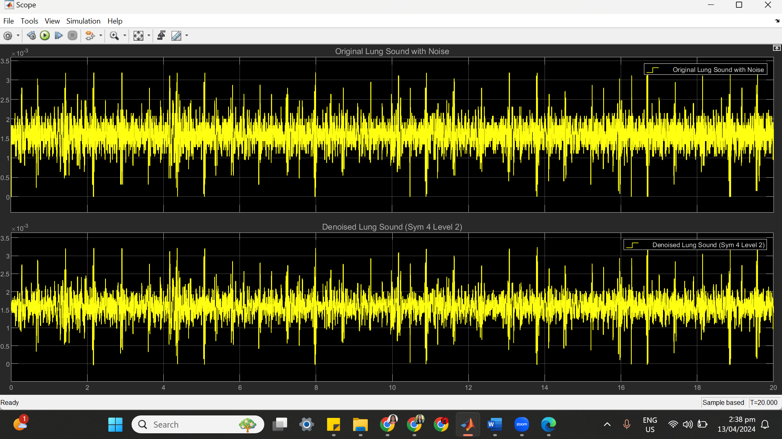

(c) SYM 4 LEVEL 2 STATISTICS RESULT

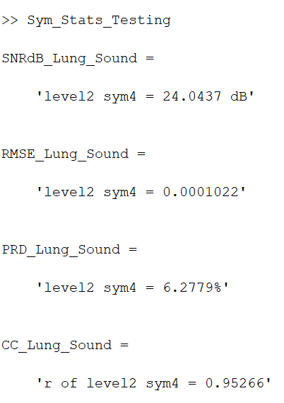

(d) SYM 4 LEVEL 2 SCATTER PLOT RESULT

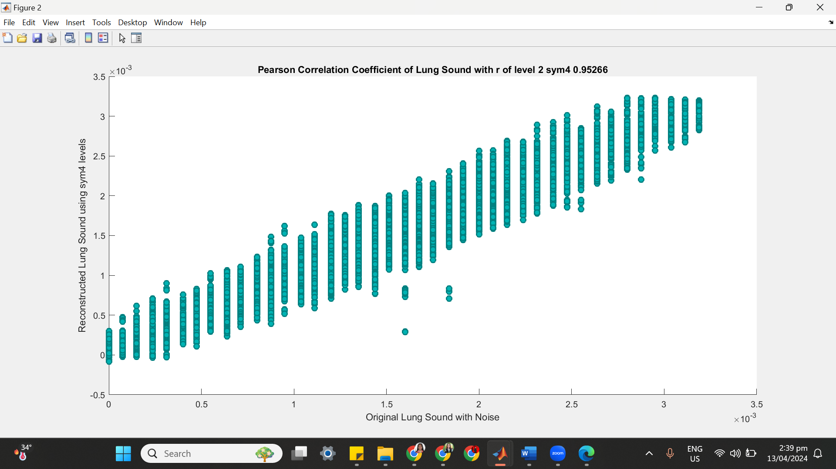

**++++++++++++++++++++++++++++++++++++++++++++++++++++++++++++++++++**

**(2) SYM 4 LEVEL 3**

(a) SYM 4 LEVEL 3 ARCHITECTURE

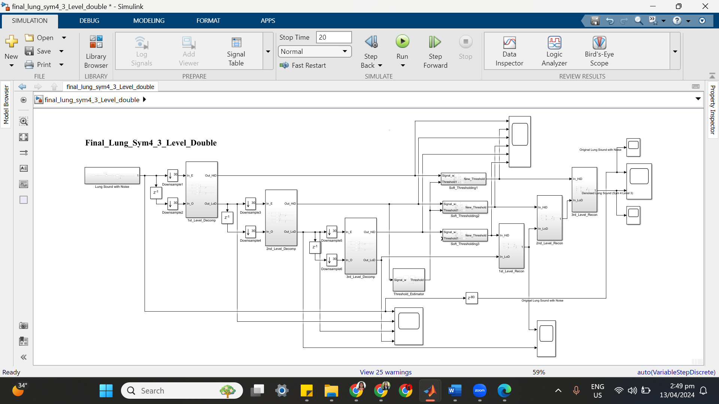

(b) SYM 4 LEVEL 3 SIMULATION RESULT

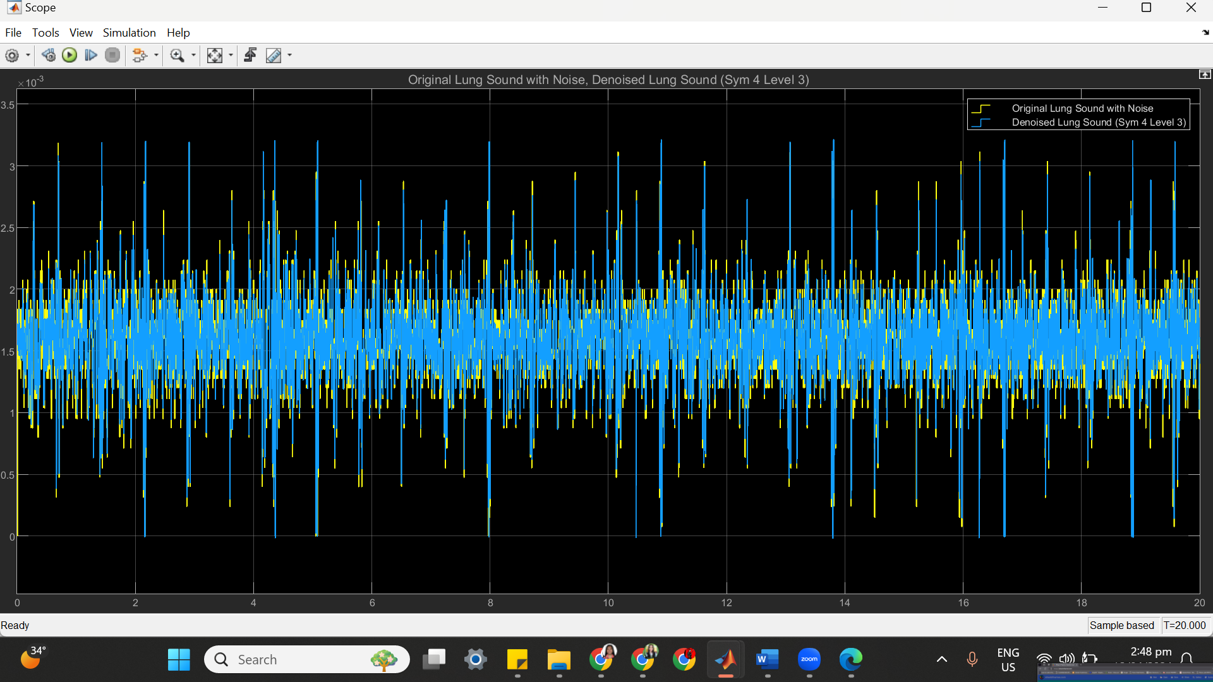

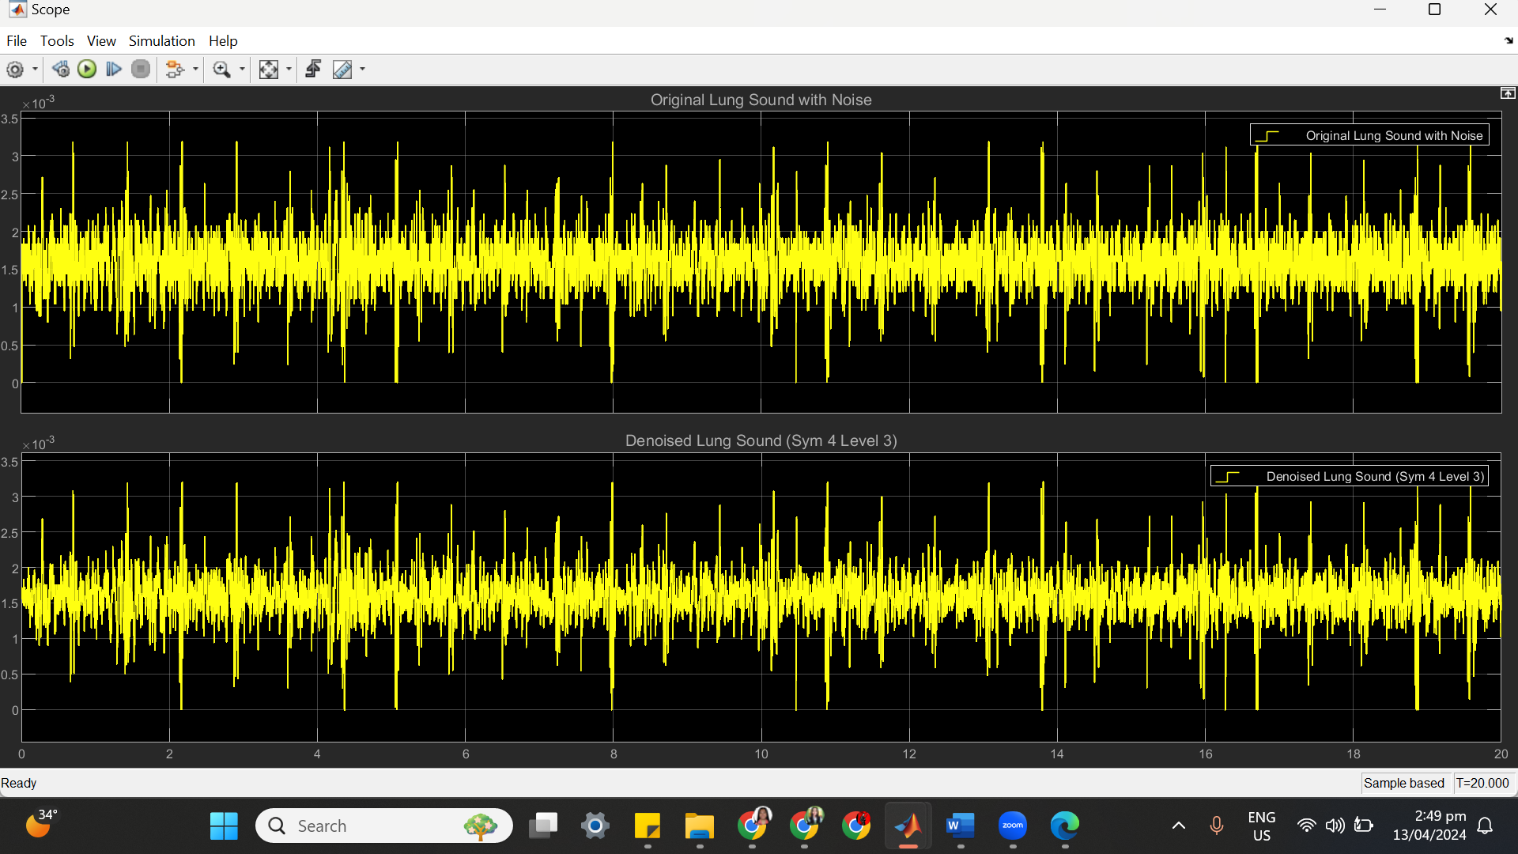

(c) SYM 4 LEVEL 3 STATISTICS RESULT

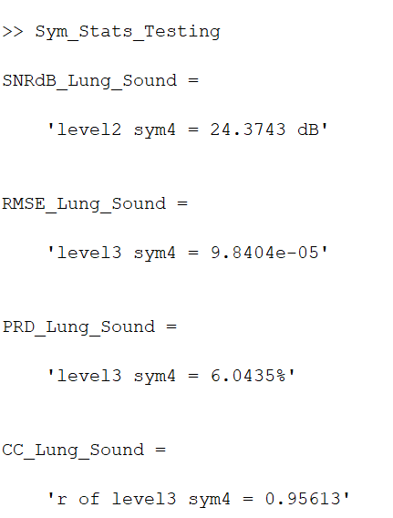

(d) SYM 4 LEVEL 3 SCATTER PLOT RESULT

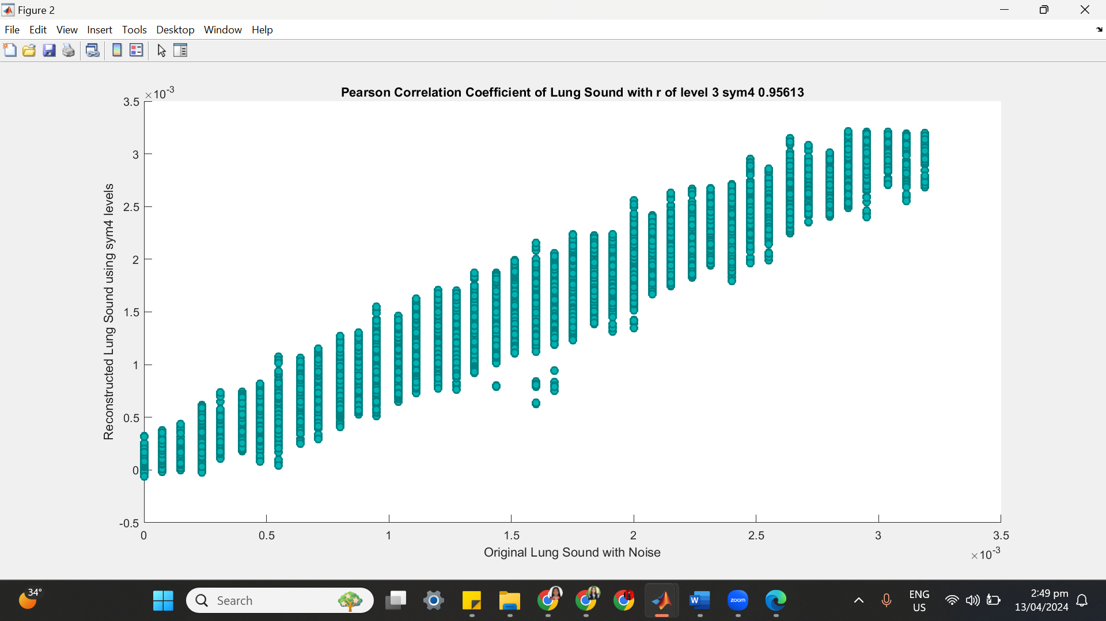

**++++++++++++++++++++++++++++++++++++++++++++++++++++++++++++++++++**

**(3) SYM 4 LEVEL 4**

(a) SYM 4 LEVEL 4 ARCHITECTURE

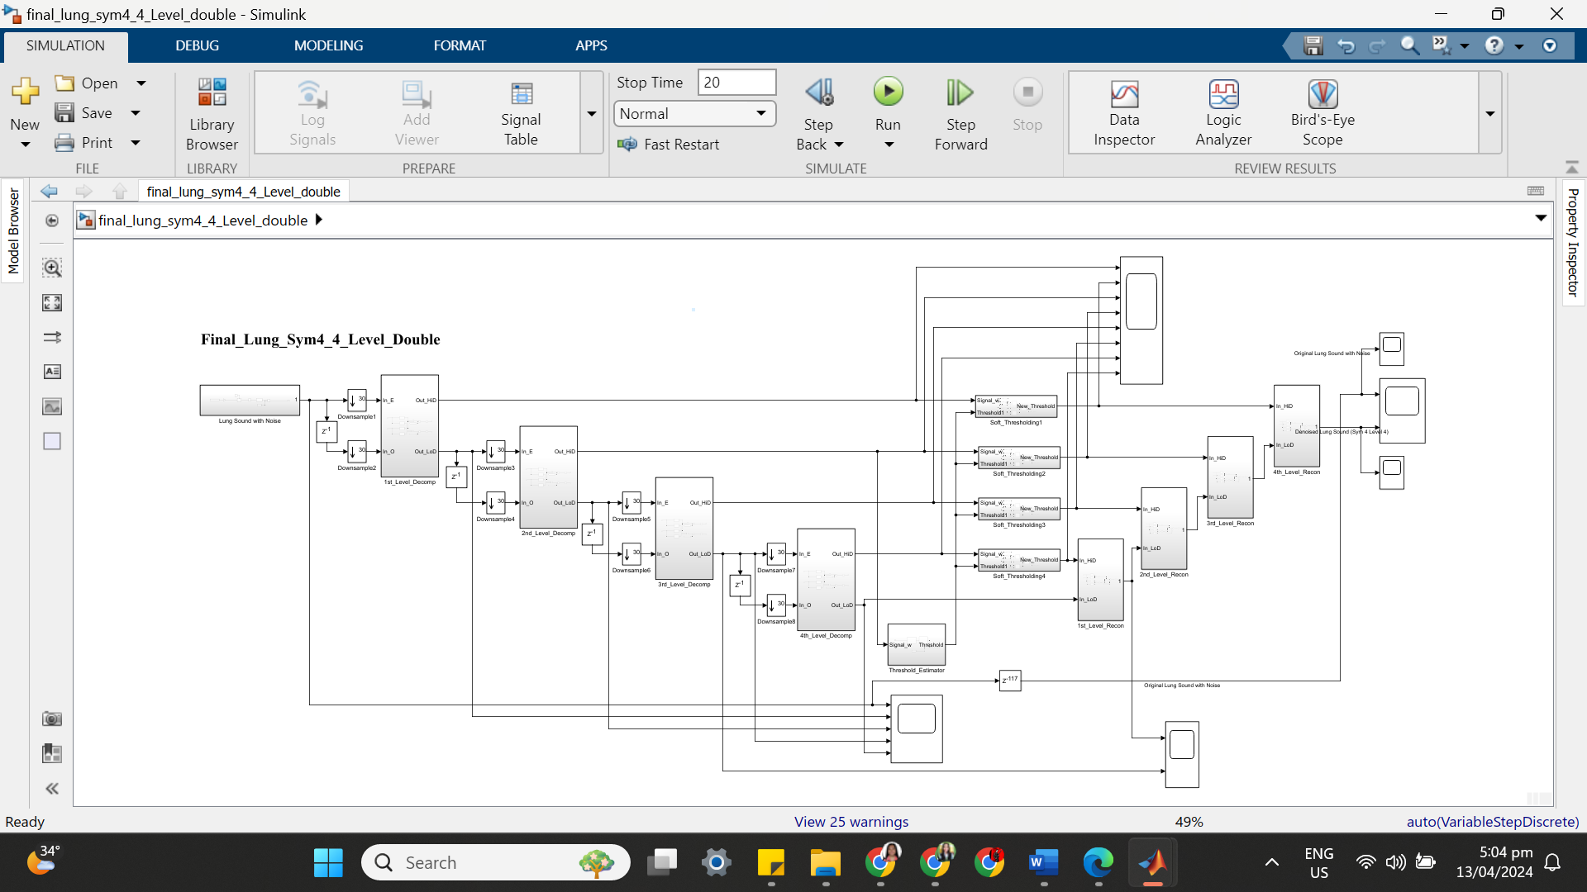

(b) SYM 4 LEVEL 4 SIMULATION RESULT

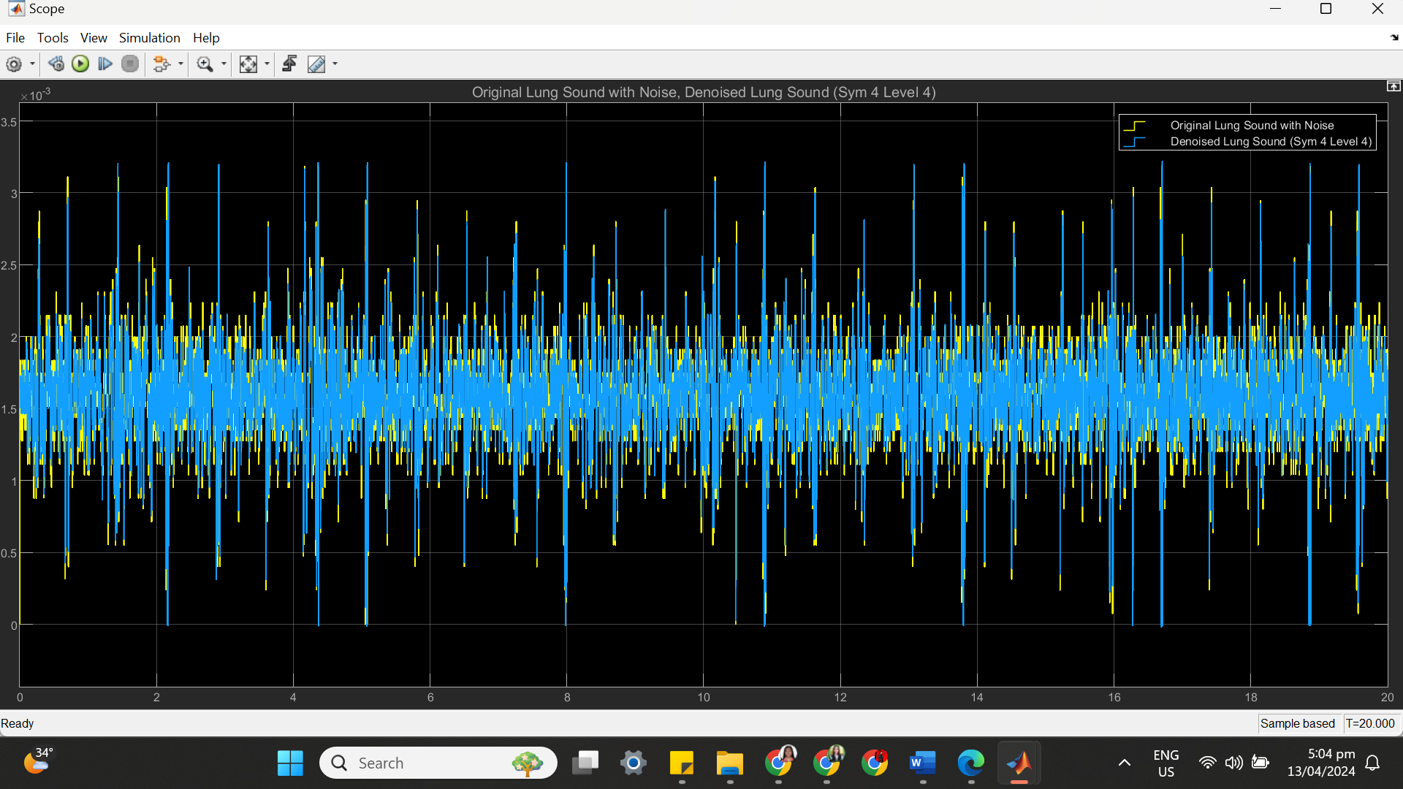

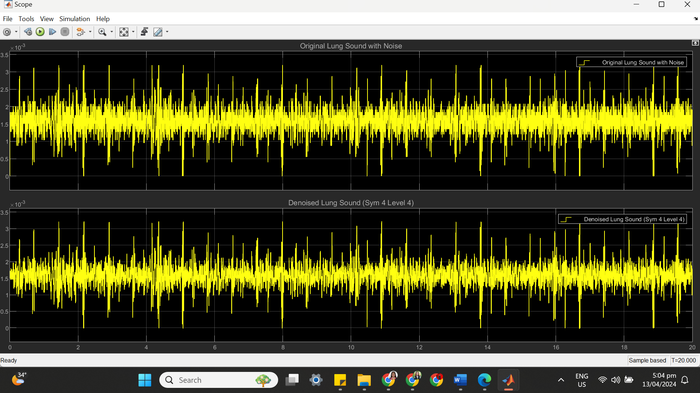

(c) SYM 4 LEVEL 4 STATISTICS RESULT

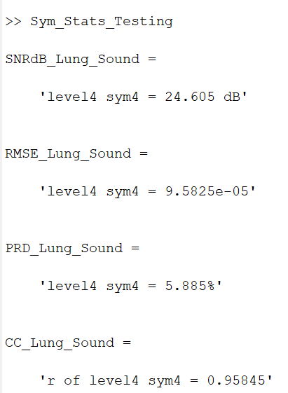

(d) SYM 4 LEVEL 4 SCATTER PLOT RESULT

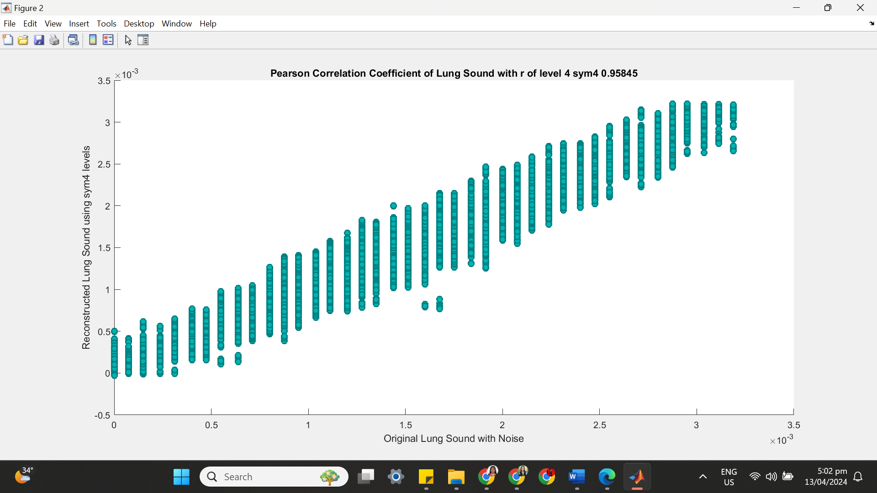

**++++++++++++++++++++++++++++++++++++++++++++++++++++++++++++++++++**

**(4) SYM 4 LEVEL 5**

(a) SYM 4 LEVEL 5 ARCHITECTURE

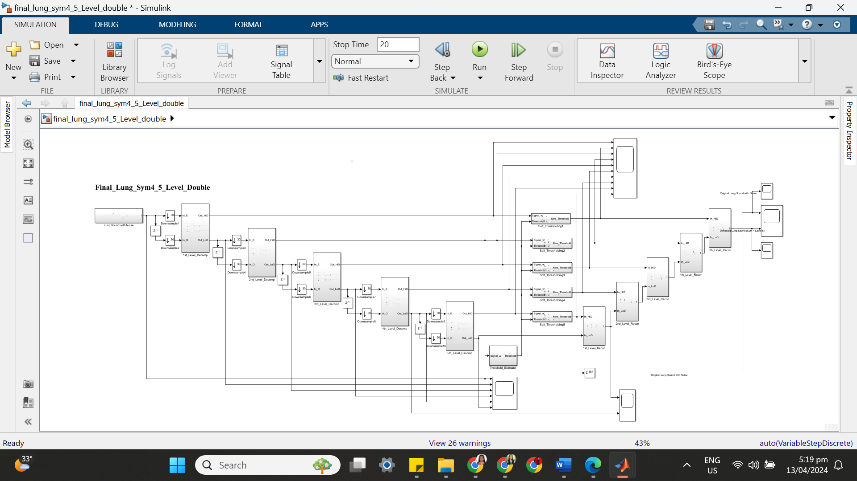

(b) SYM 4 LEVEL 5 SIMULATION RESULT

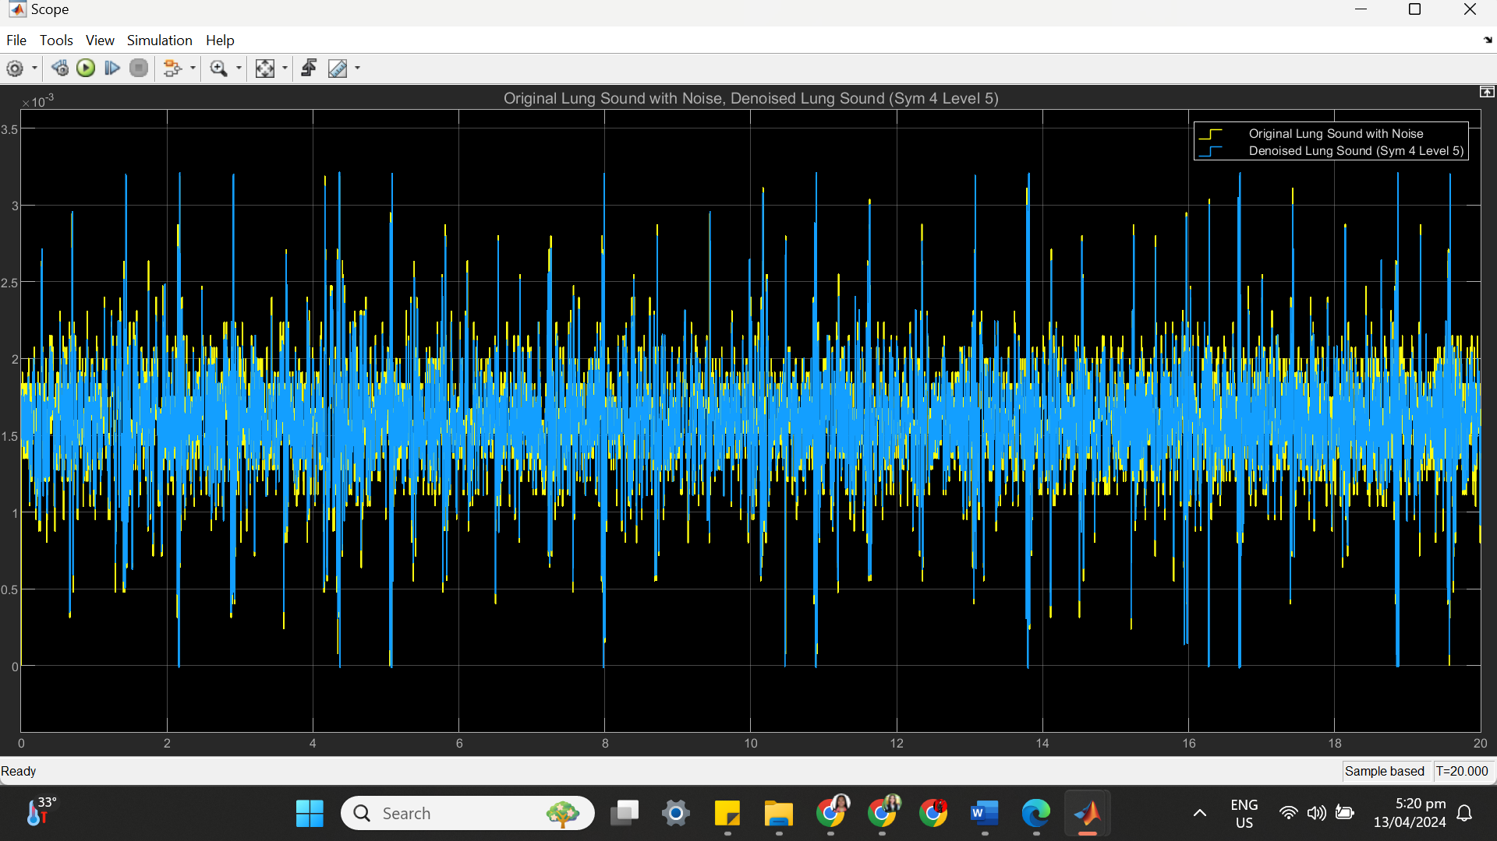

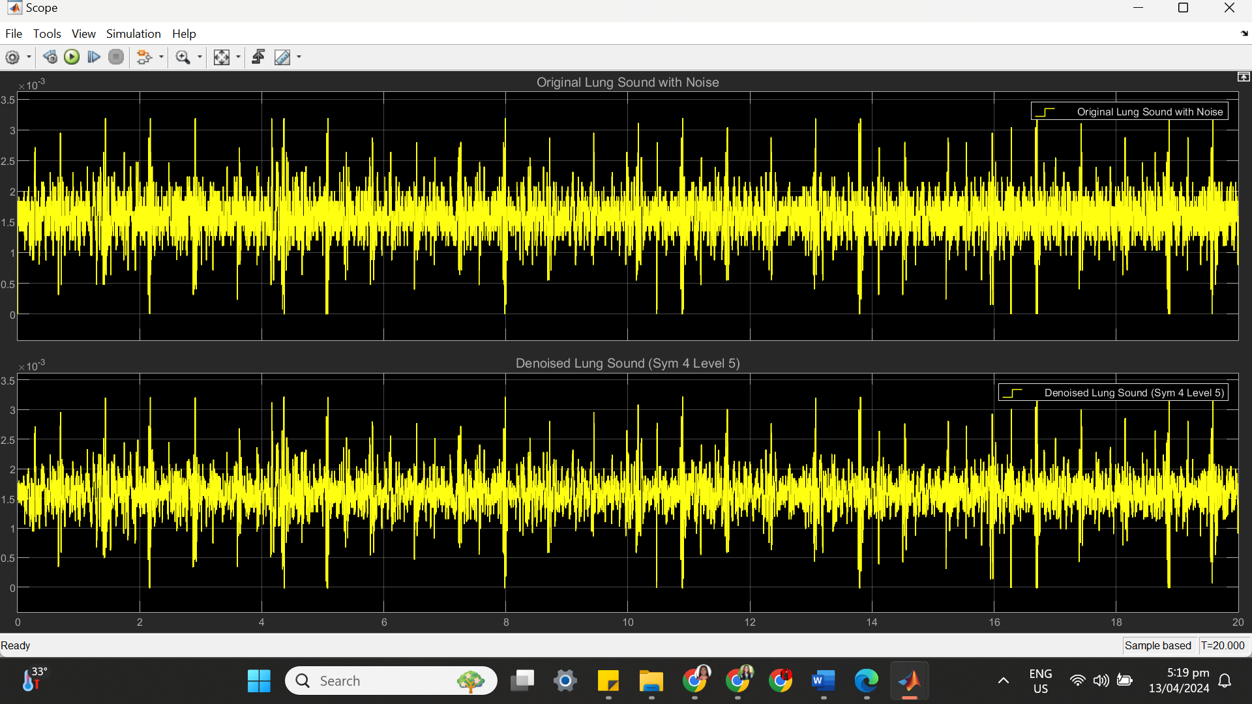

(c) SYM 4 LEVEL 5 STATISTICS RESULT

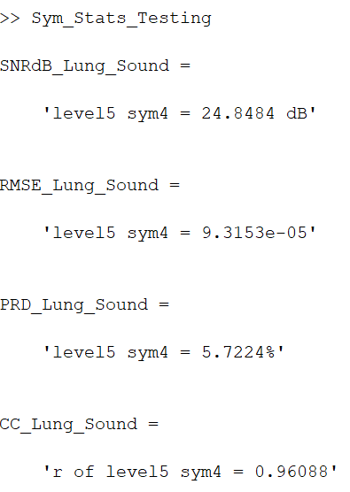

(d) SYM 4 LEVEL 5 SCATTER PLOT RESULT

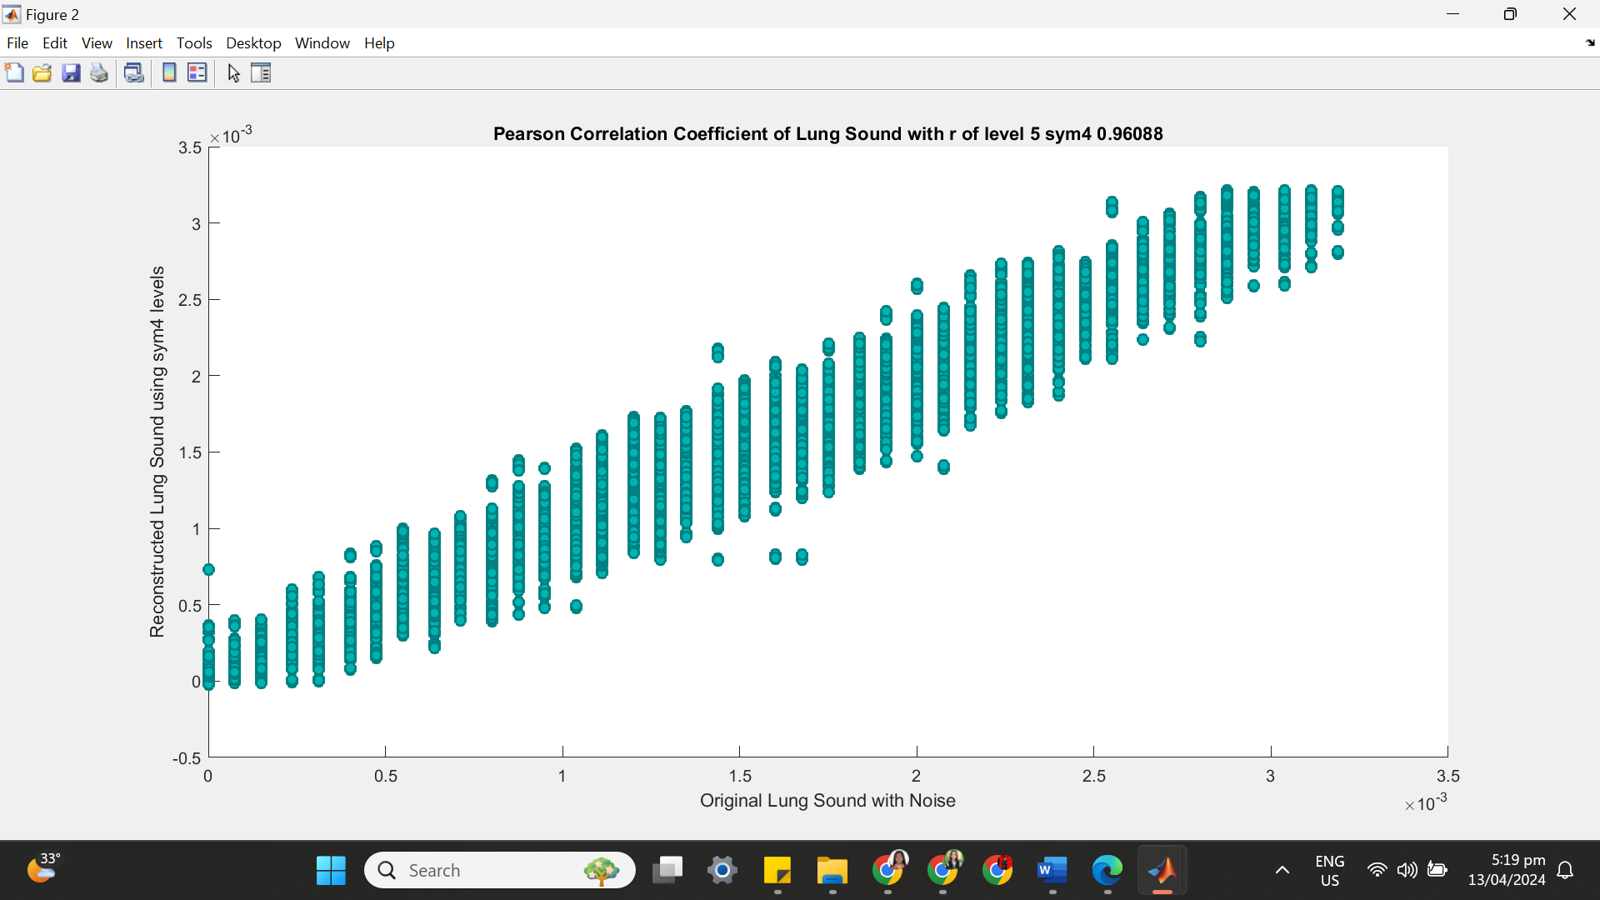

**++++++++++++++++++++++++++++++++++++++++++++++++++++++++++++++++++**

**(5) SYM 4 LEVEL 6**

(a) SYM 4 LEVEL 6 ARCHITECTURE

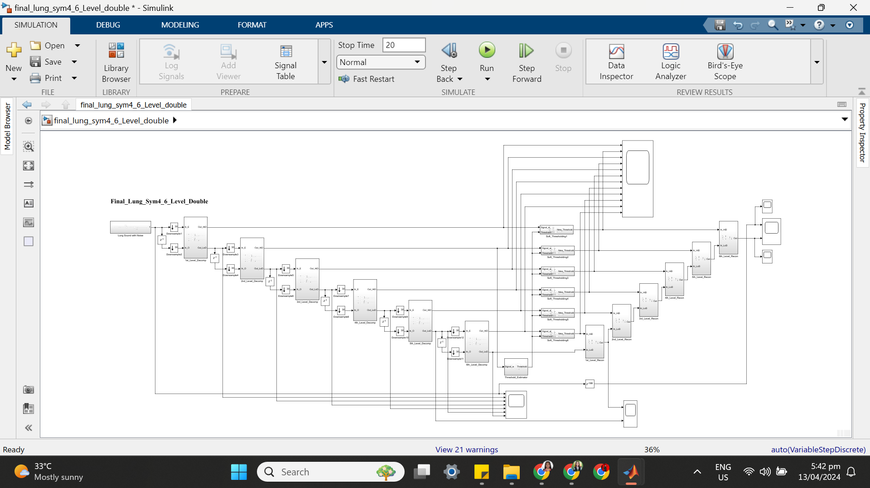

(b) SYM 4 LEVEL 6 SIMULATION RESULT

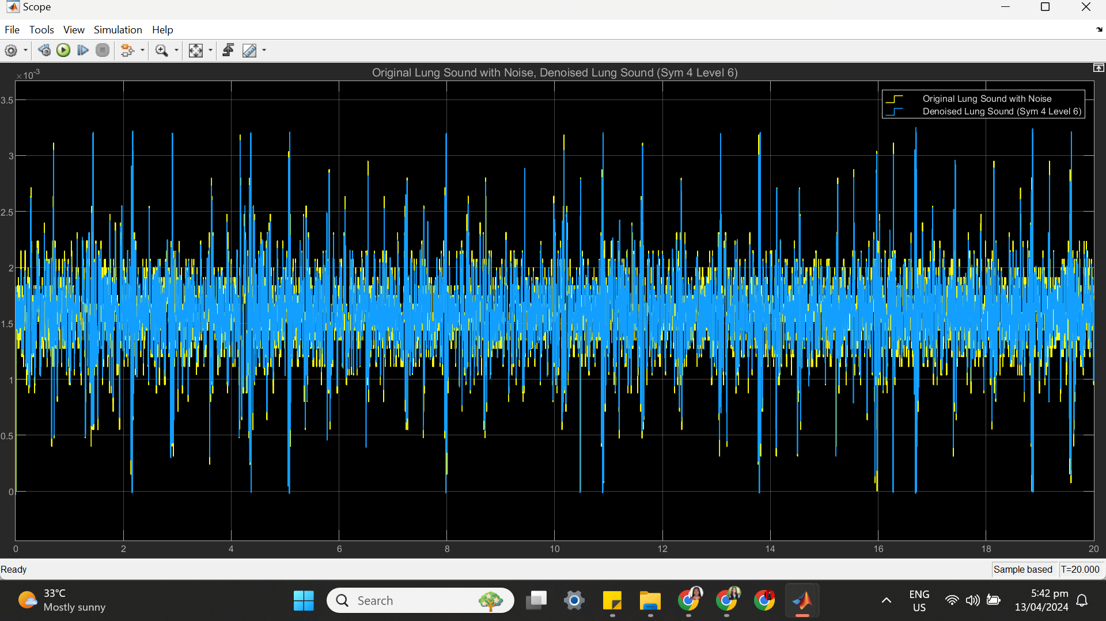

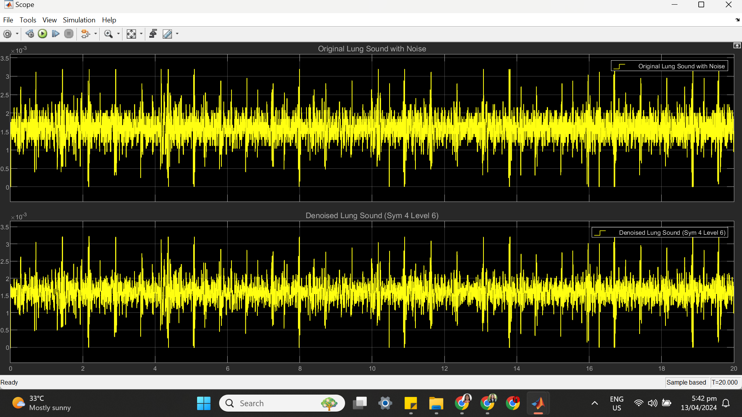

(c) SYM 4 LEVEL 6 STATISTICS RESULT

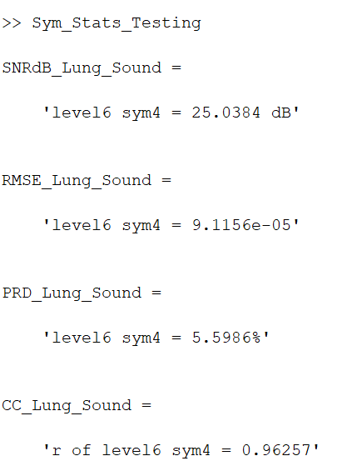

(d) SYM 4 LEVEL 6 SCATTER PLOT RESULT

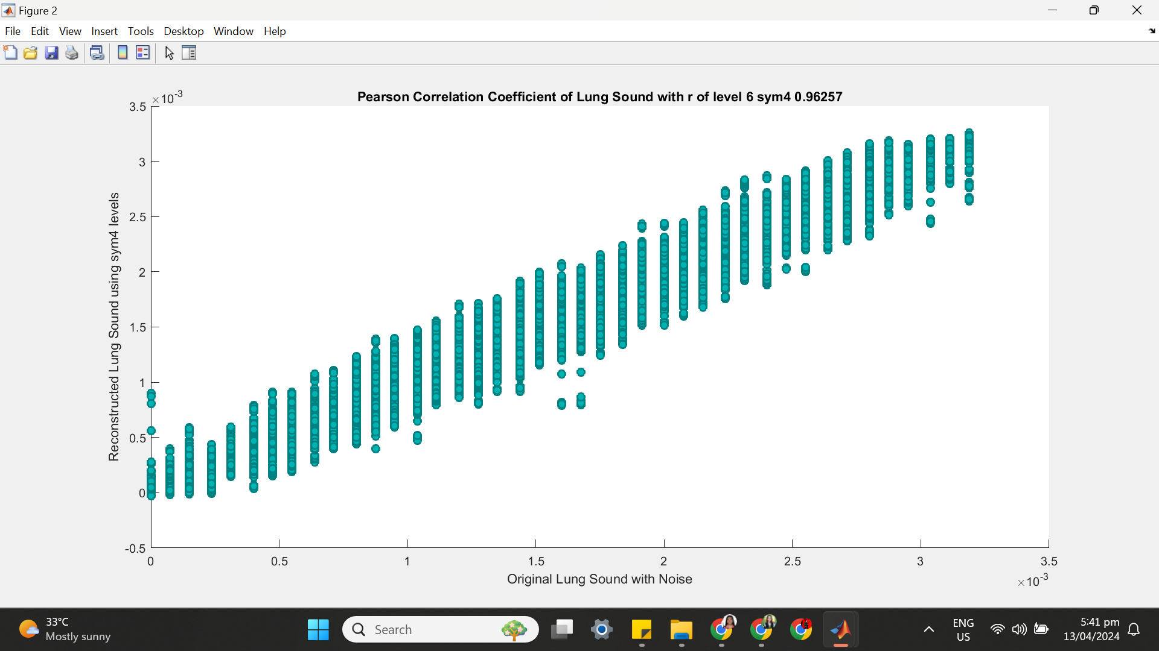

**++++++++++++++++++++++++++++++++++++++++++++++++++++++++++++++++++**

**(6) SYM 4 LEVEL 7**

(a) SYM 4 LEVEL 7 ARCHITECTURE

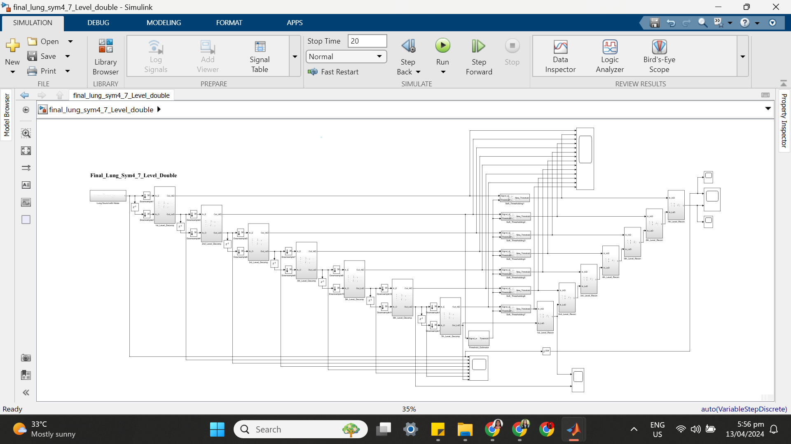

(b) SYM 4 LEVEL 7 SIMULATION RESULT

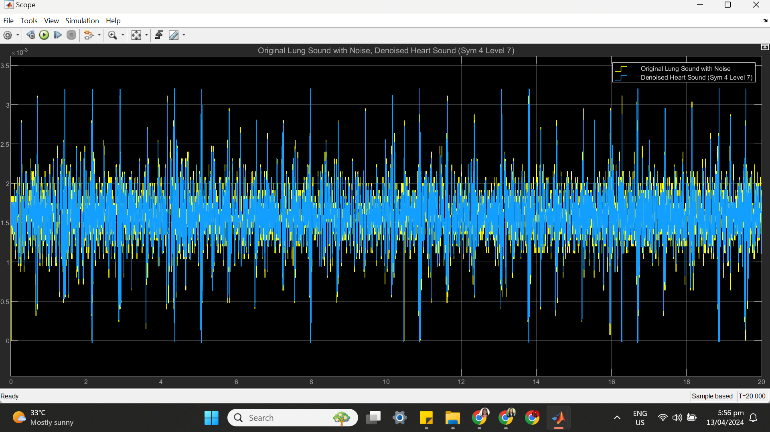

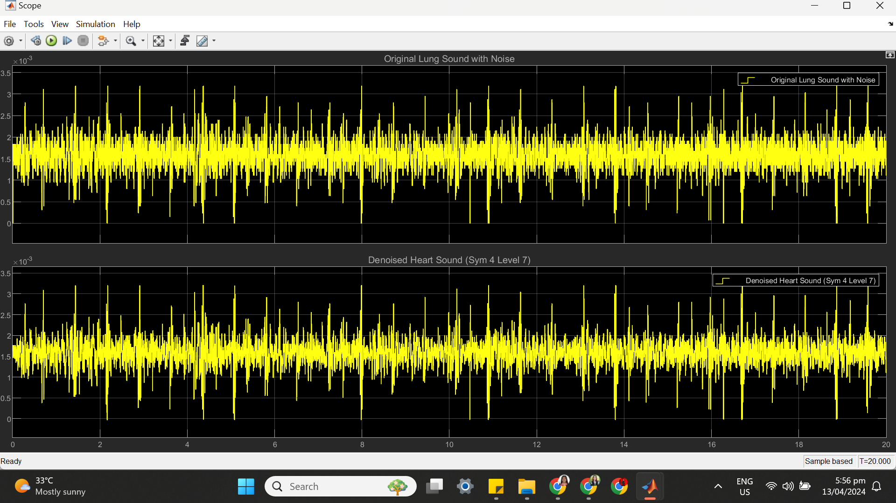

(c) SYM 4 LEVEL 7 STATISTICS RESULT

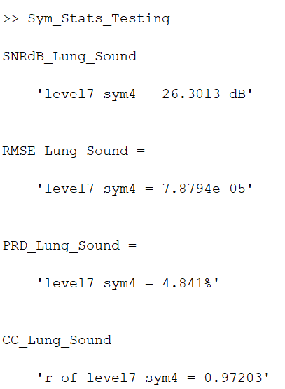

(d) SYM 4 LEVEL 7 SCATTER PLOT RESULT

